# Advanced Generators and Coroutines in Python 3

## Generators

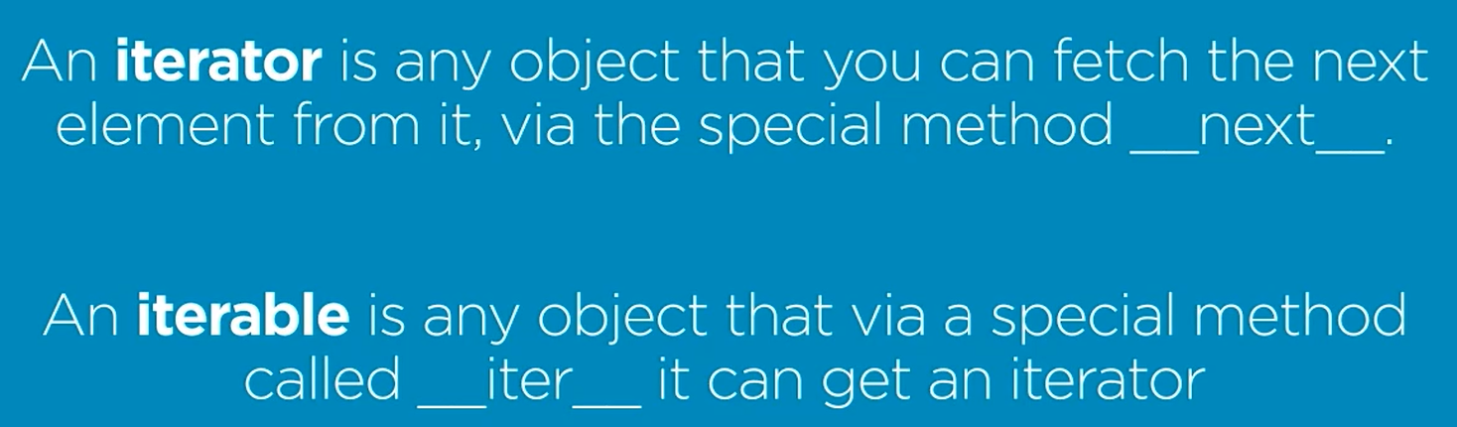

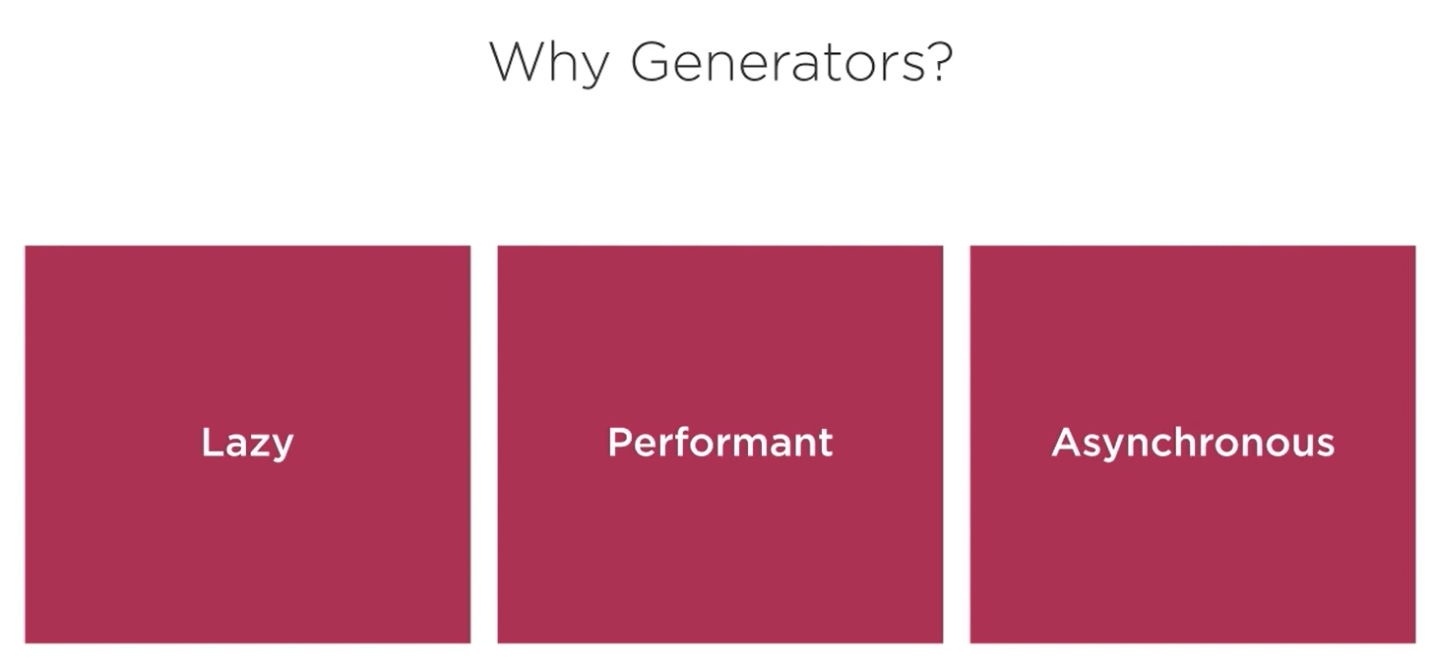

**A generator is any python function that has yield statement.**

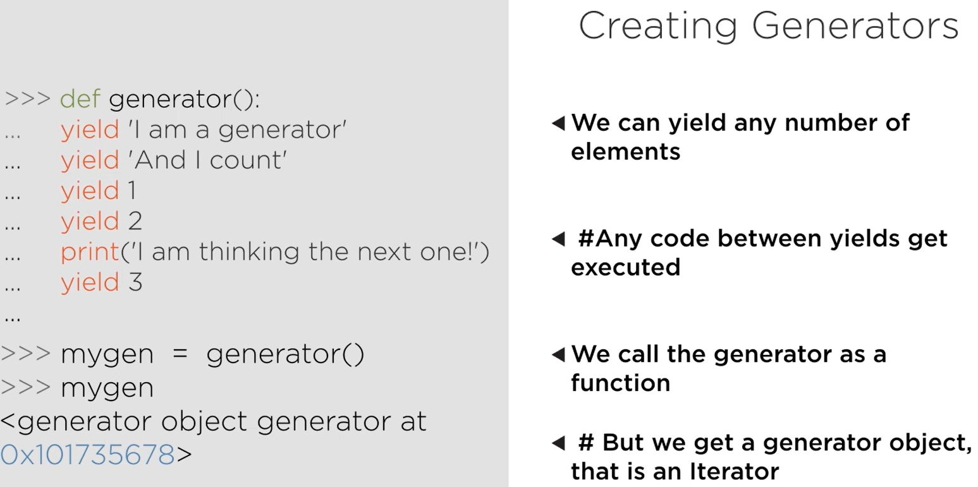

Generator Expression:

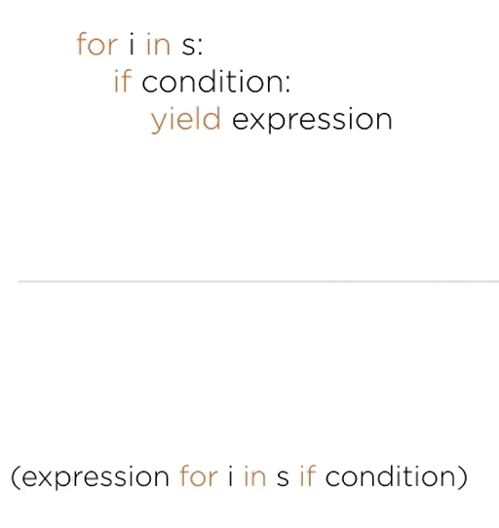

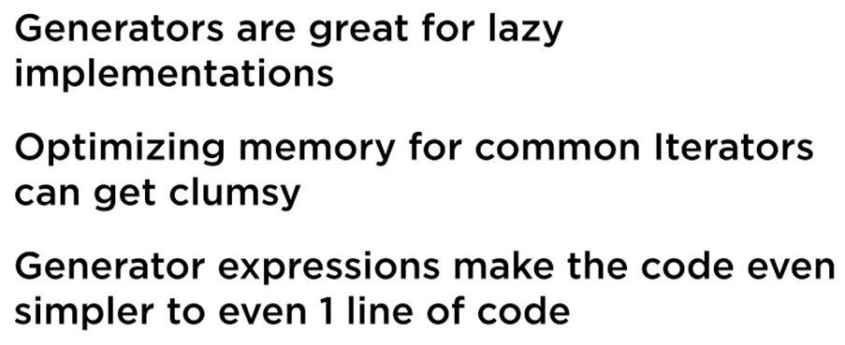

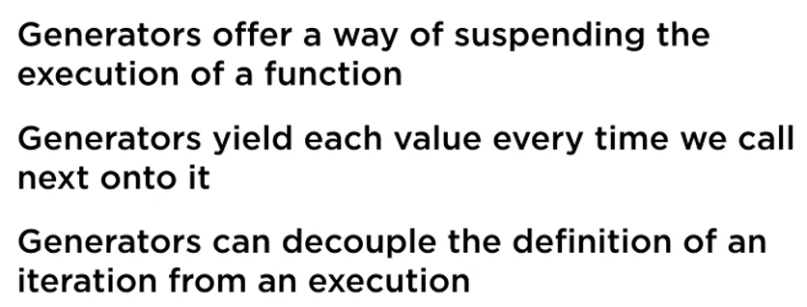

## Generator Based Data Pipeline

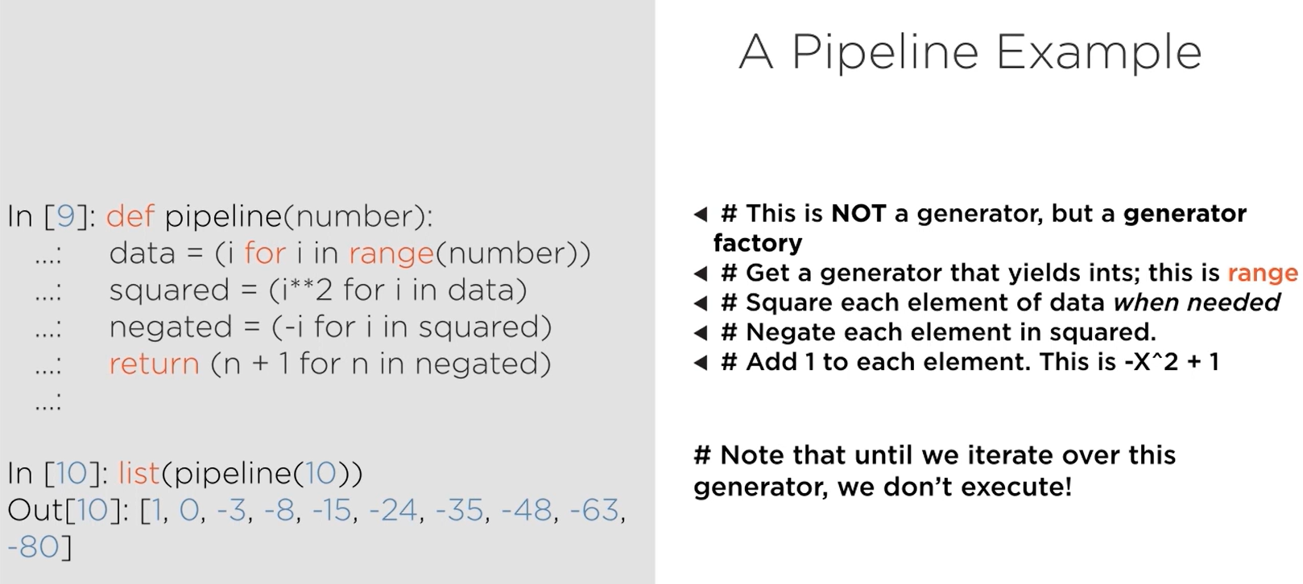

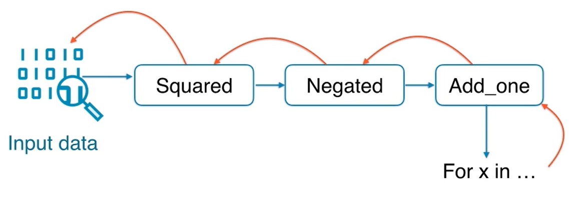

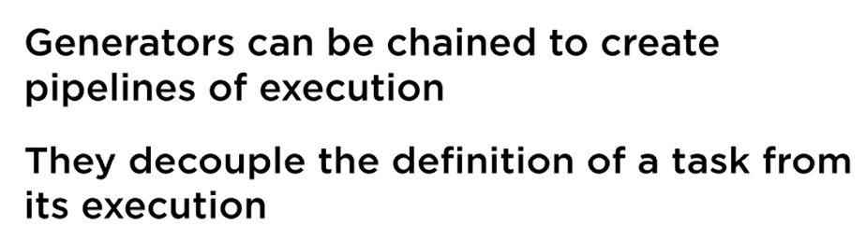

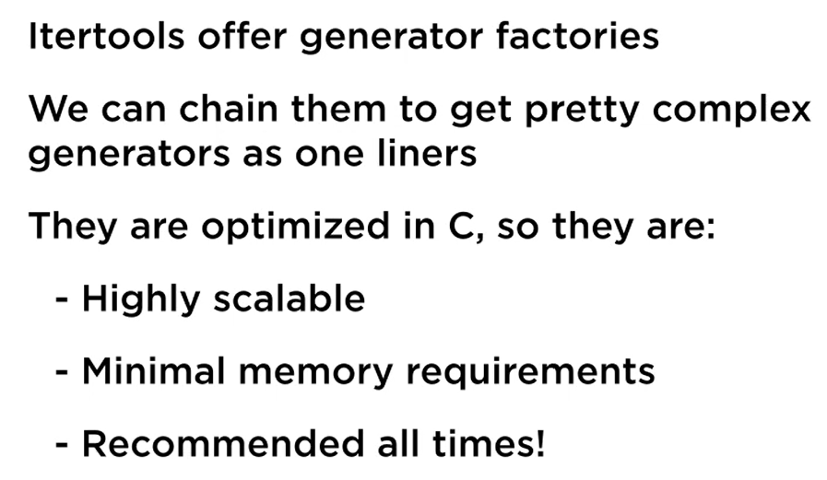

## Generators Counterpart: Coroutines

Beyond the scope of this doc

# Unit Testing with Python 3

## Unit Test Fundamentals

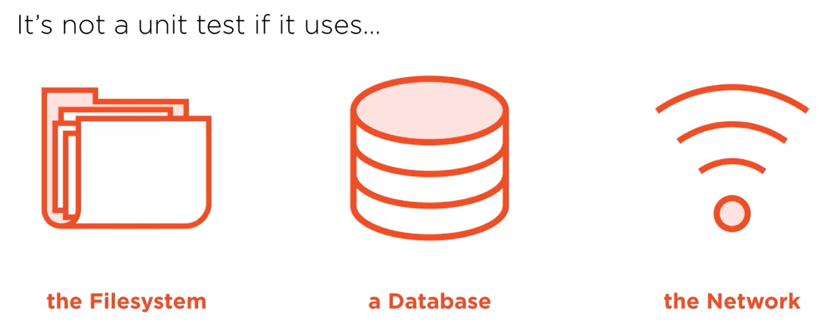

Problem Statement:

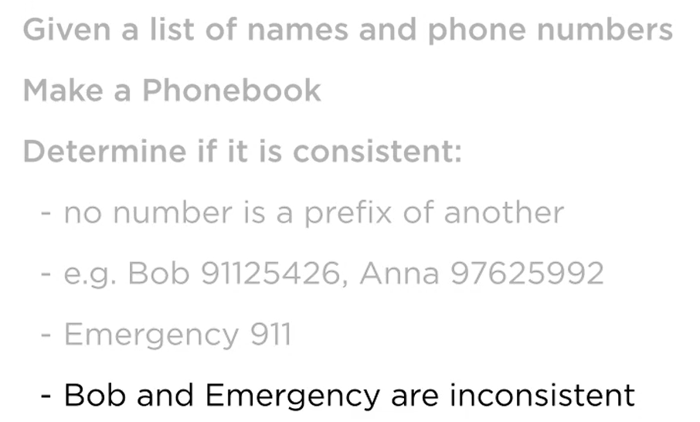

Refer folder unit_test.

To run the test, make sure pwd has the test file and then execute this at terminal:

python -m unittest

python -m pytest

You can also take advantage of built in test runner in VSCode for running tests.

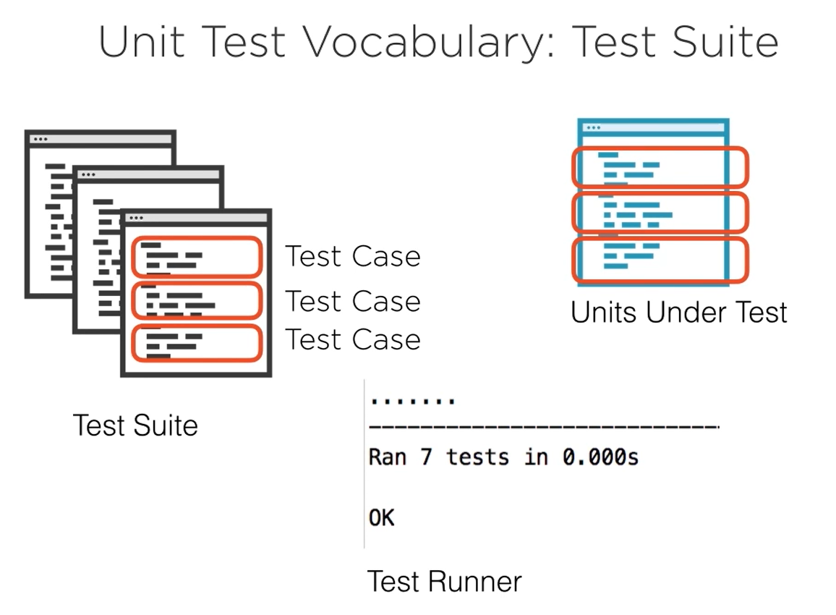

Test Suite can be made up of multiple test cases from several different classes.

Skip a unit test from being executed by annotating the test with:

**@unittest.skip(“reason”)**

method setUp() called before every test method in the class (can be used for data setup for every test, resource allocation)

method tearDown() called after every test method in the class (can be used to release resources that were set up in setup method like database connection, file resource, etc)

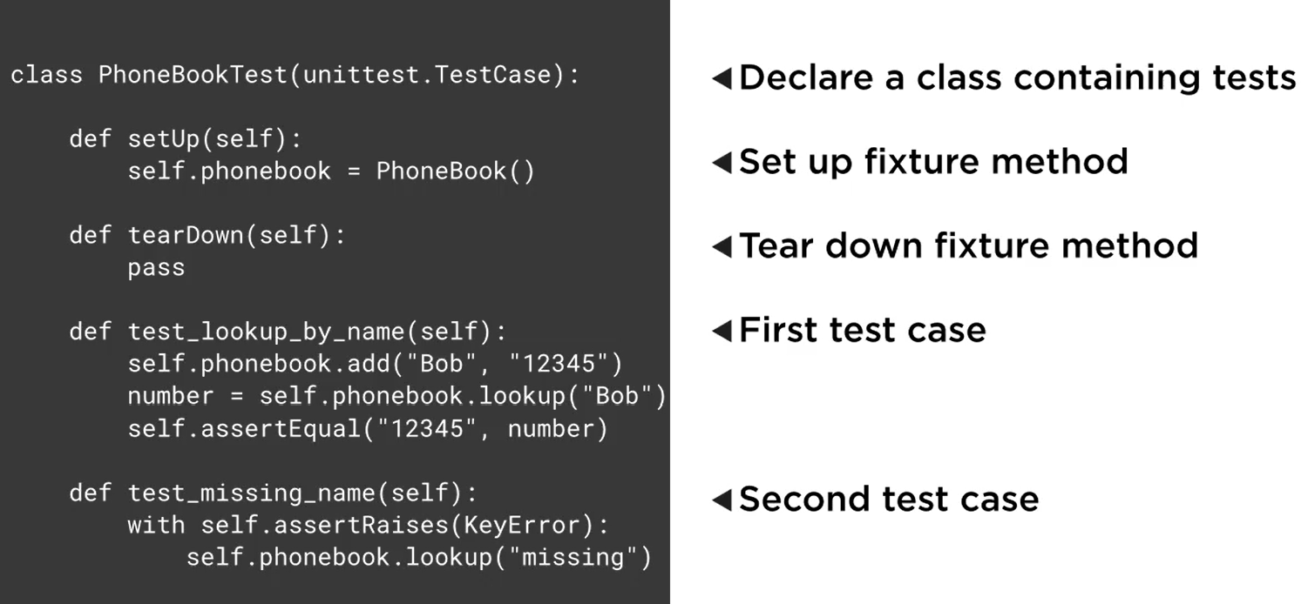

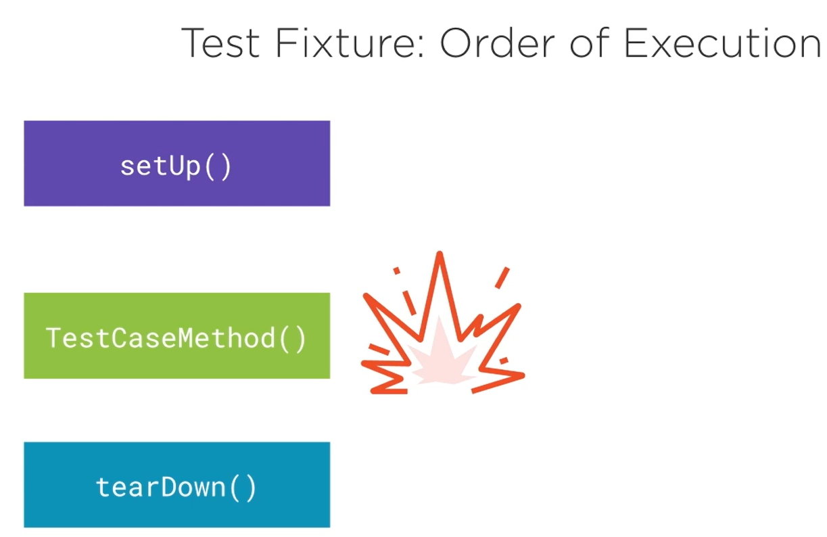

If there is any error in setUp method, none of the other methods will be called

If there is error in the TestCaseMethod, teardown method will still be called

While designing test case, do not test multiple things in one test case (do not try to club more than one scenario in a test case)

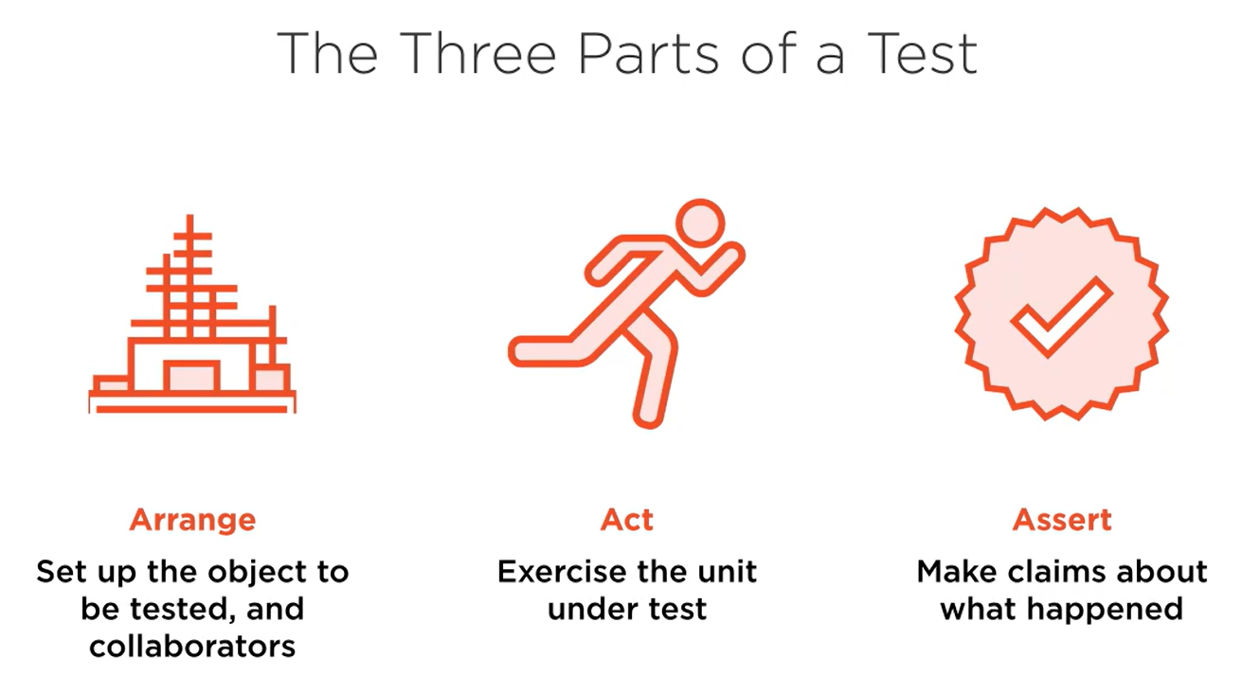

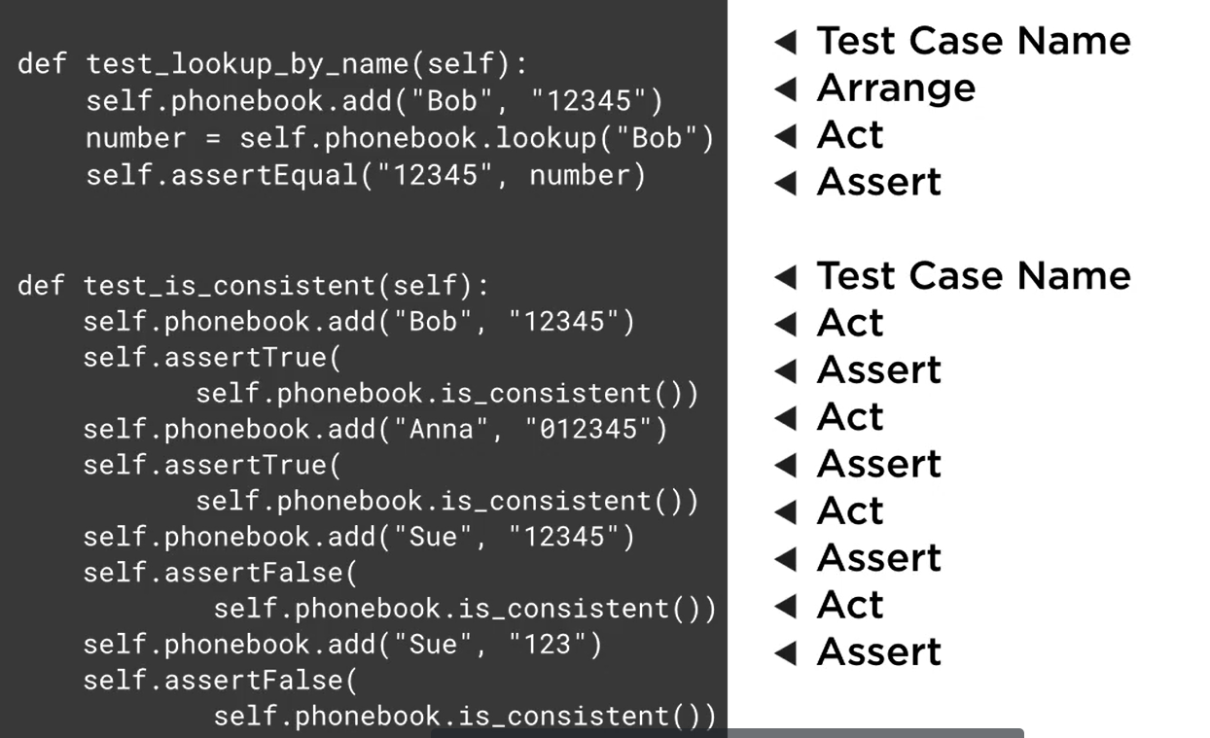

The first example has a good design, the second one has bad design.

## Unit Testing Why and When

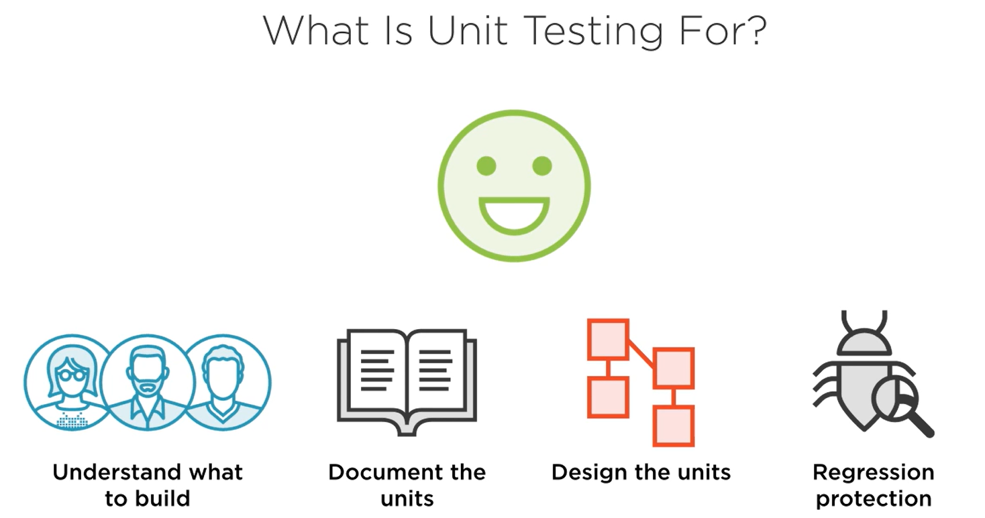

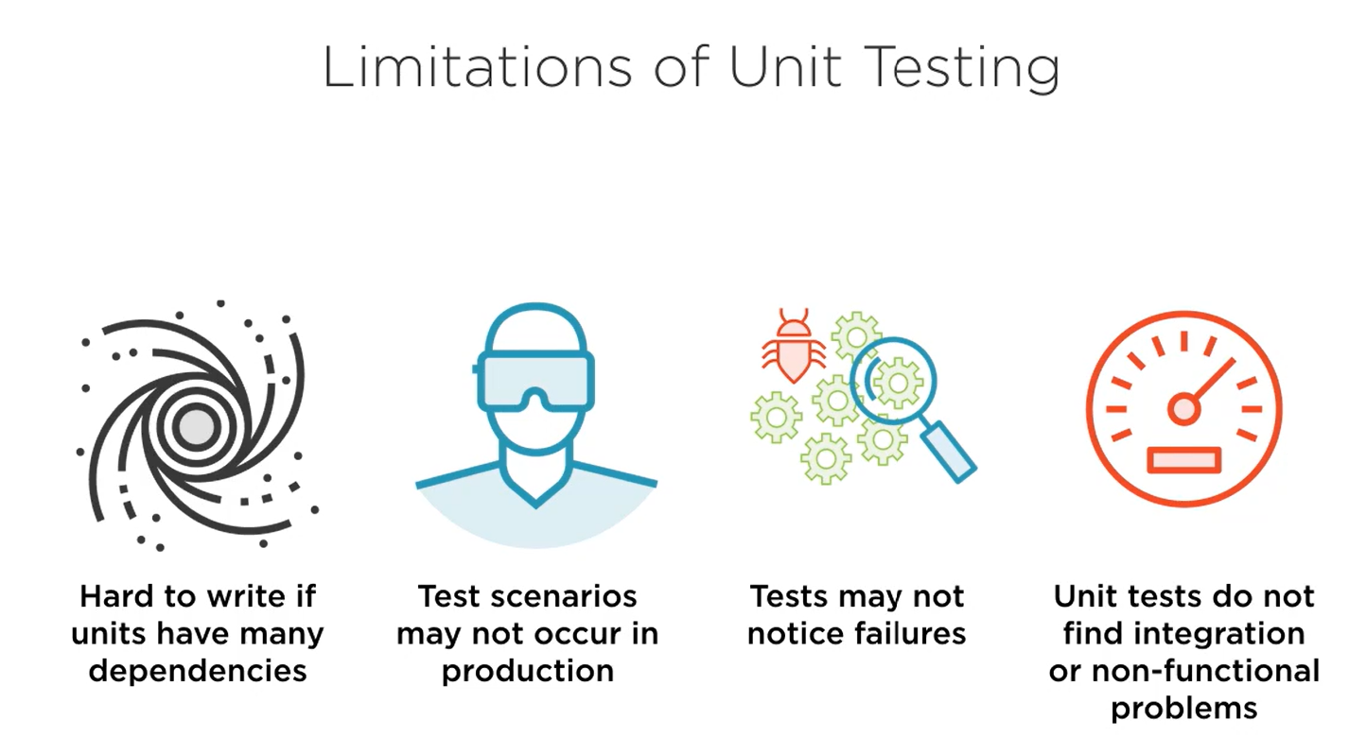

When to write tests

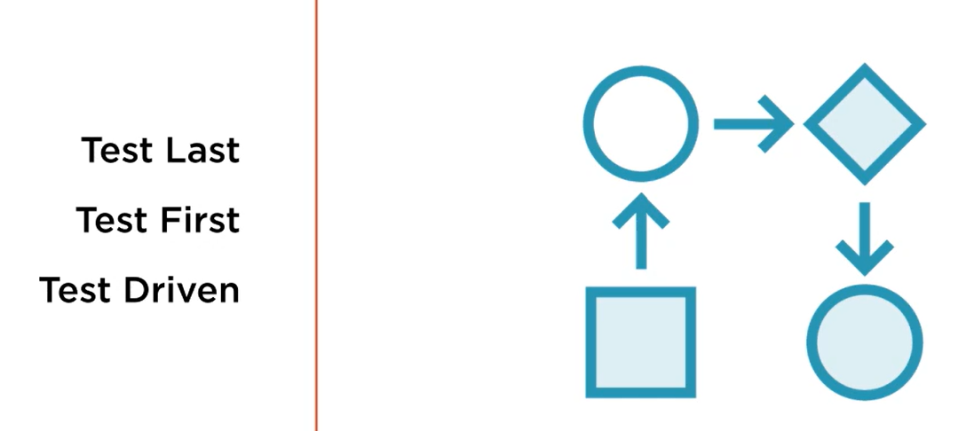

### Test Last

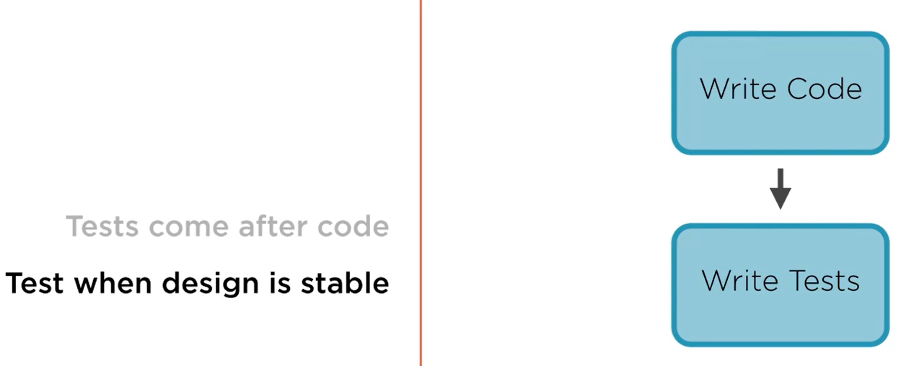

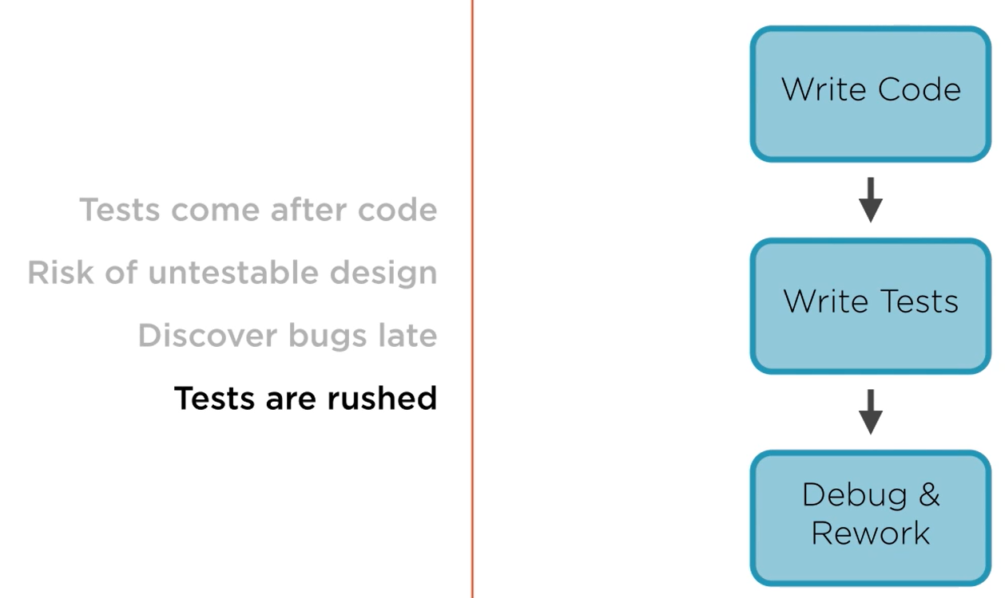

### Test First

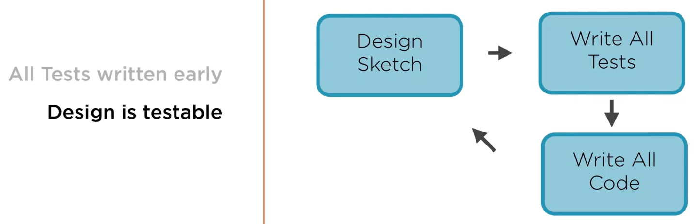

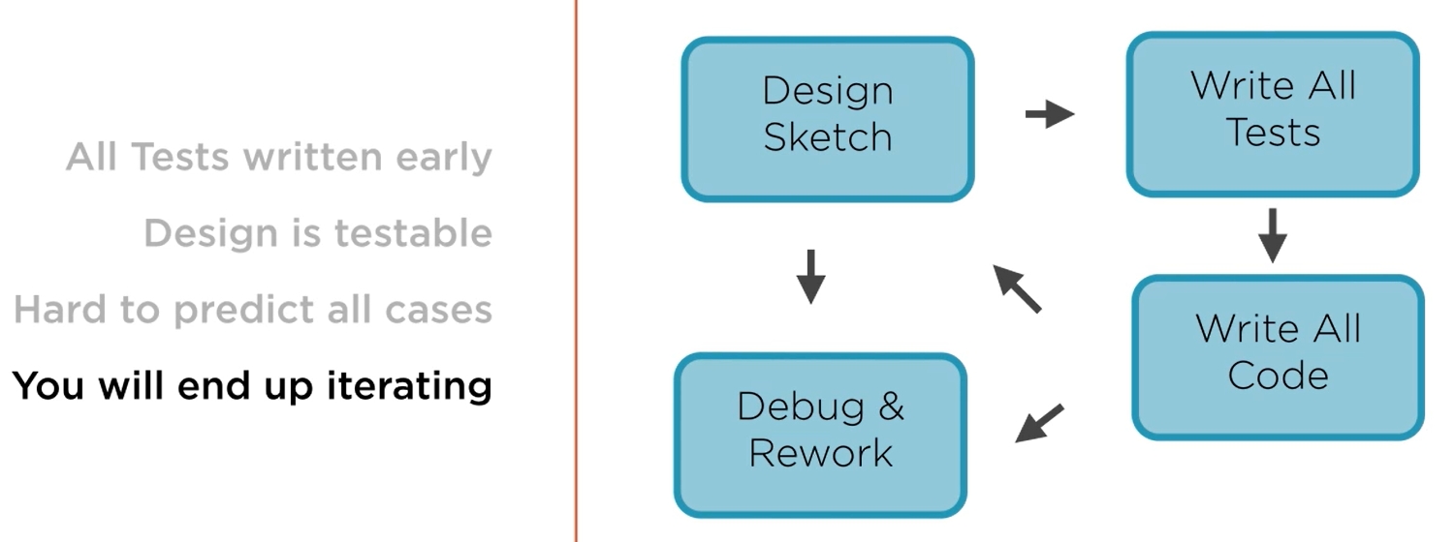

### Test Driven Development

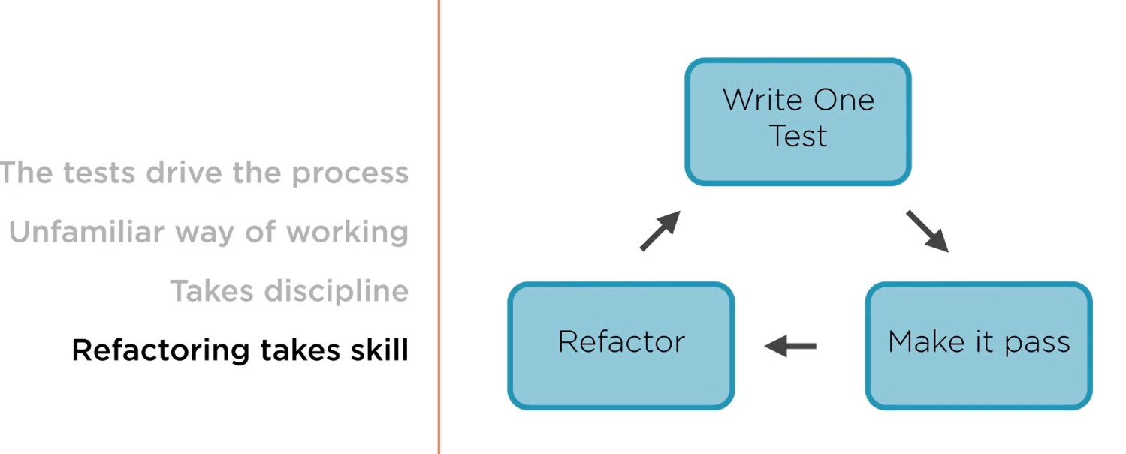

## Unit Testing with pytest

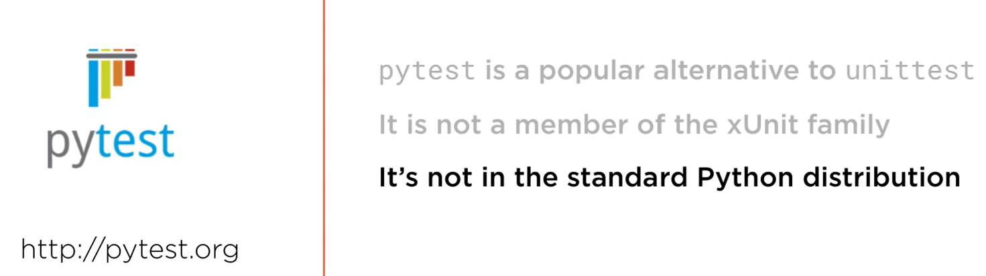

To run the test, make sure pwd has the test file and then execute this at terminal:

python -m pytest

You can also take advantage of built in test runner in VSCode for running tests.

### Test Fixture

In unittest:

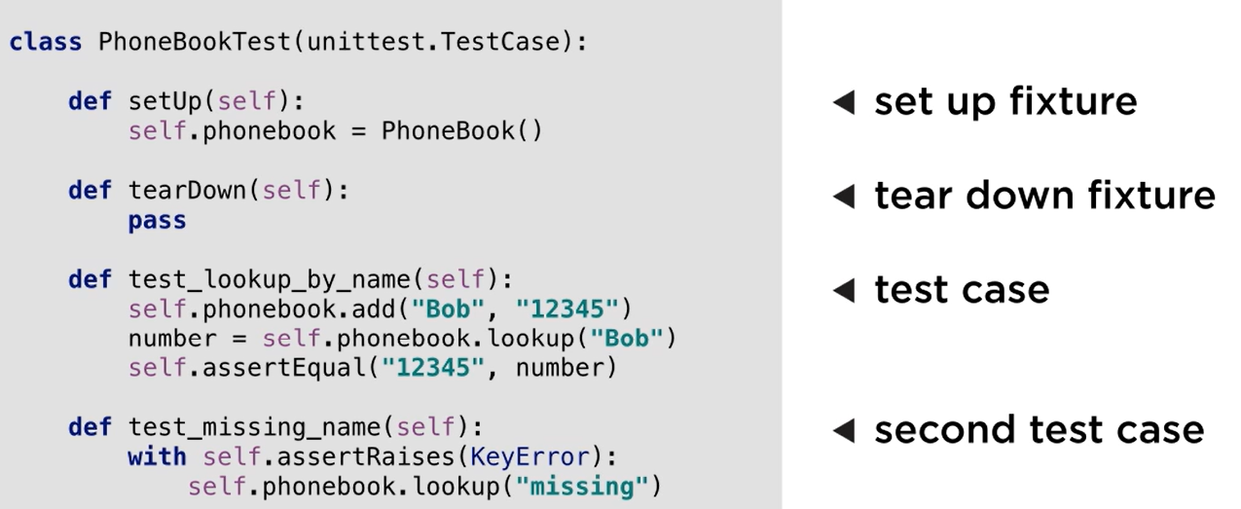

In pytest:

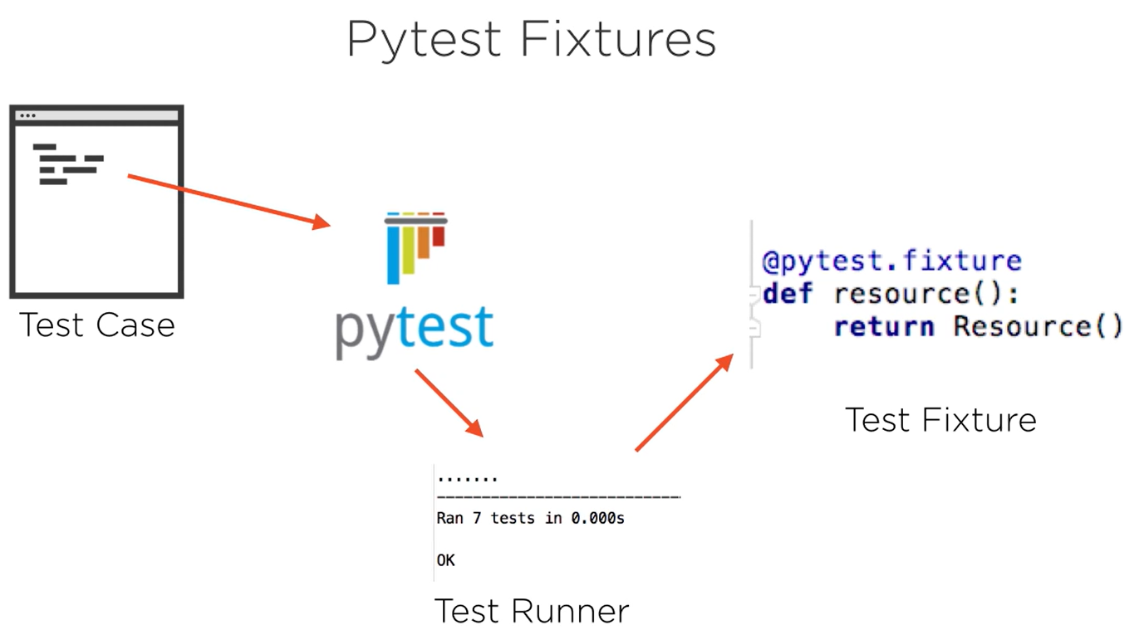

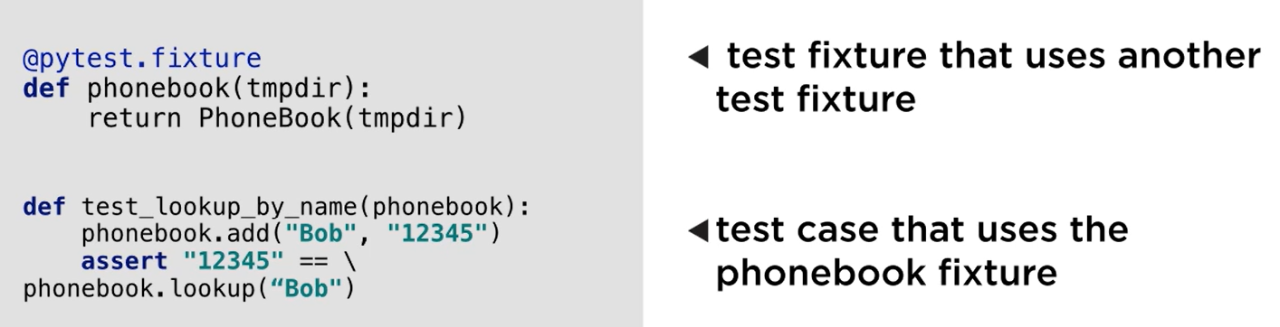

To get a list of fixtures supported by pytest, run the following command:

**pytest –fixtures**

**There is a way to parametrize a fixture, which can be found in test_example.py.**

### Organizing Test Code for larger Programs

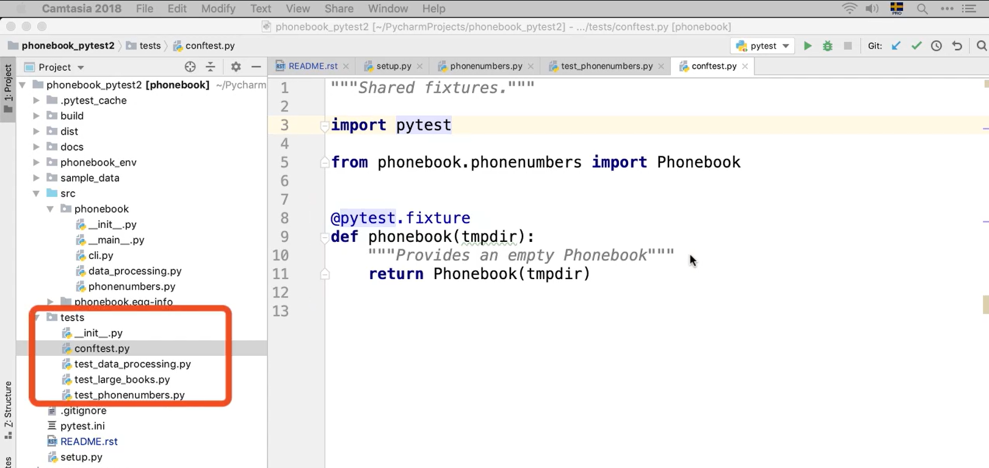

conftest.py is a file which contains all the fixtures and the fixtures defined here are accessible to all the files in this folder as well as sub-folders.

|  |  |  |
| --- | --- | --- |
|  | **unittest** | **pytest** |
| **Test Fixture** | Methods:   * setup() * tearDown() | Chart  Description automatically generated  Use resource as argument in the test methods  To get all the fixtures, run:  **pytest --fixtures** |
| **Skip Test** | @unittest.skip(“reason”) | @pytest.mark.skip(“reason”)  @pytest.mark.skipif(condition, “reason”)  Use markers  To get all markers, run  **python -m pytest --markers** |

## Testable documentation with doctest

Refer folder YatzyGameWithDocTest

To run doctest, execute either of the following:

* python -m doctest <filename_with_extension> -v
* python -m pytest --doctest-modules

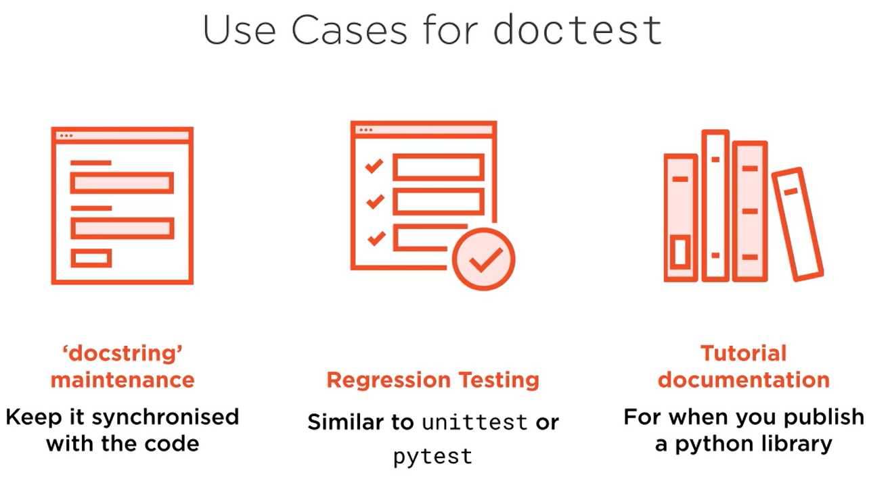

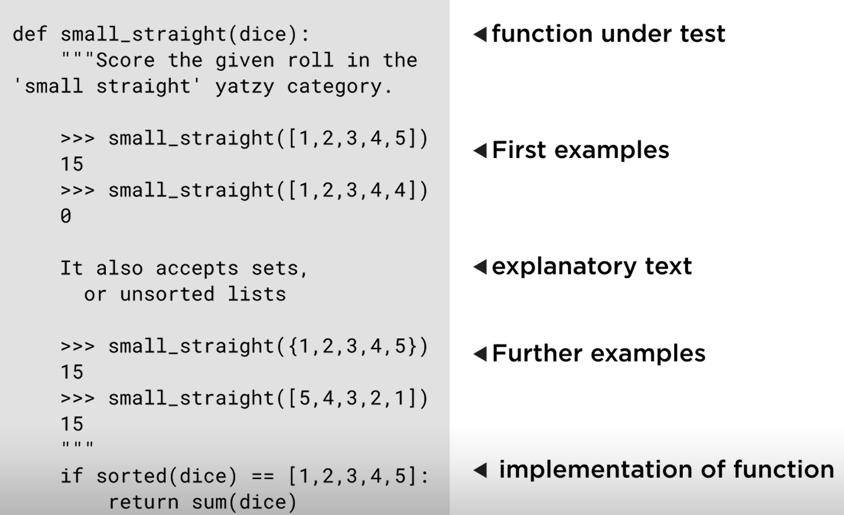

There is more to this section which I think Is not required at the moment.

Handling Output that Varies using a Wildcard

Handling Random Numbers

## Using Test Doubles: Mocks, Stubs & Fakes

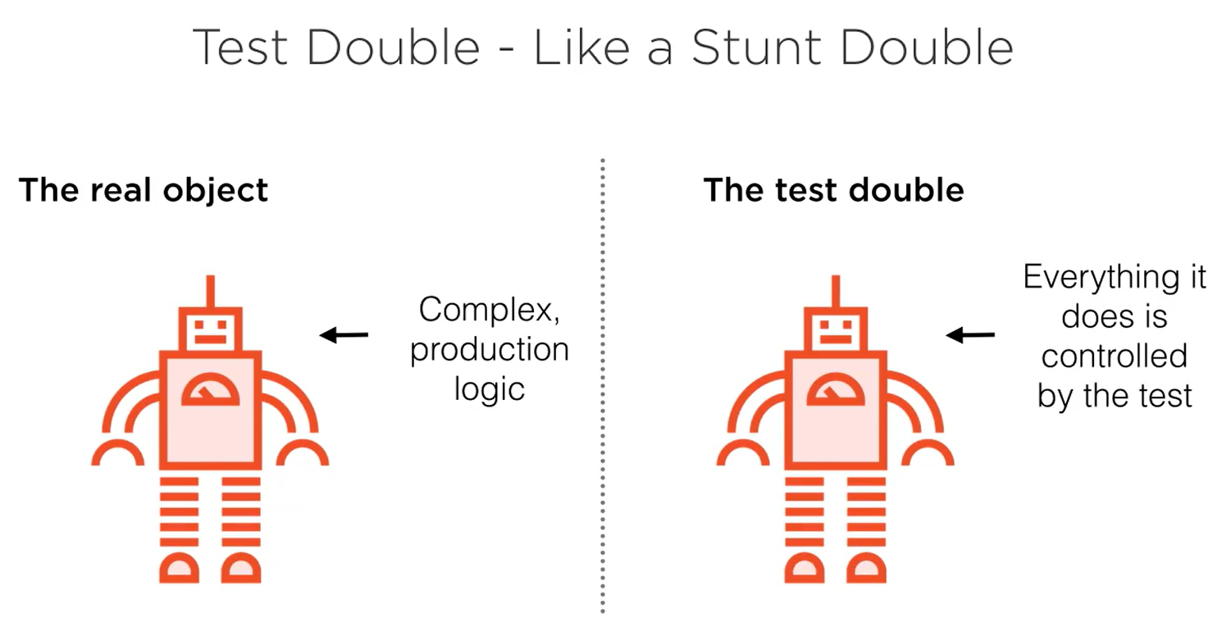

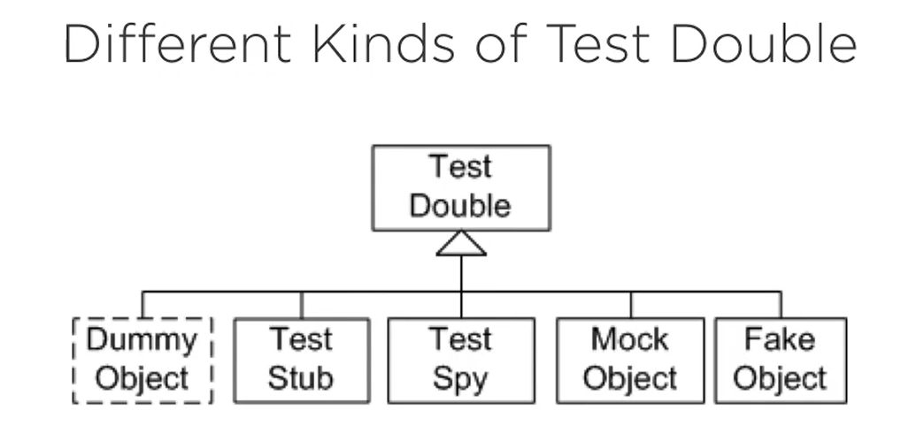

dummy is None

stub, spy, mock are all similar and created using unitest.Mock

fake is more similar to exact implementation

Refer folder TirePressure

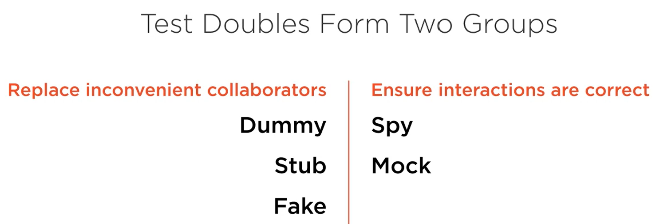

### Stub

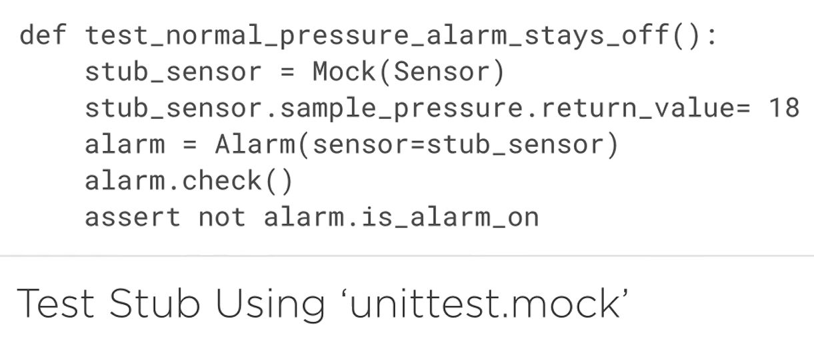

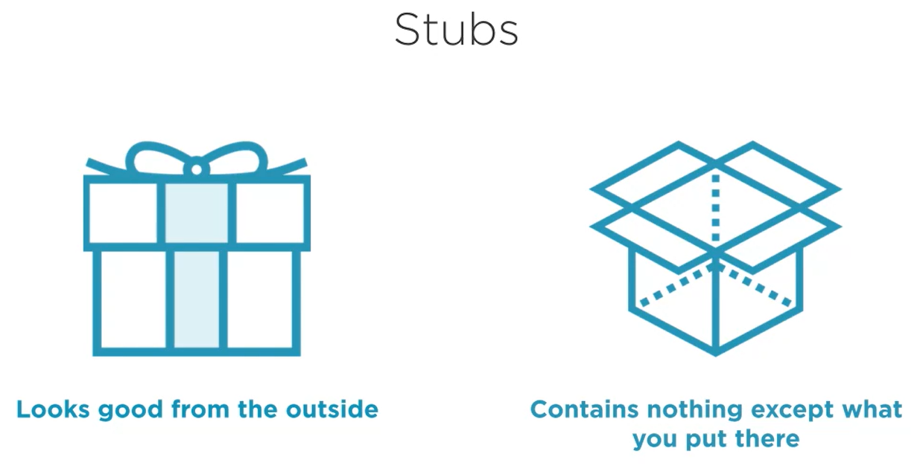

### Fake

When there are a lot of methods, stub does not make a lot of sense as you will have to take care of all the methods. Fakes make it easier.

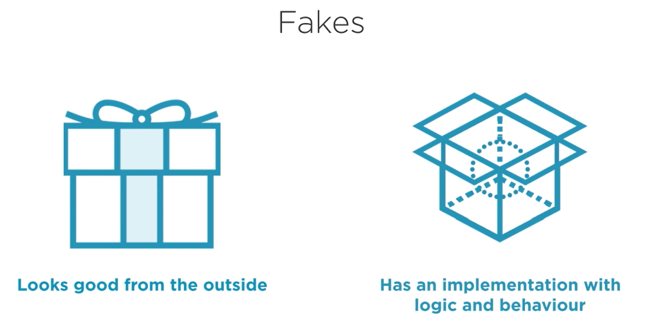

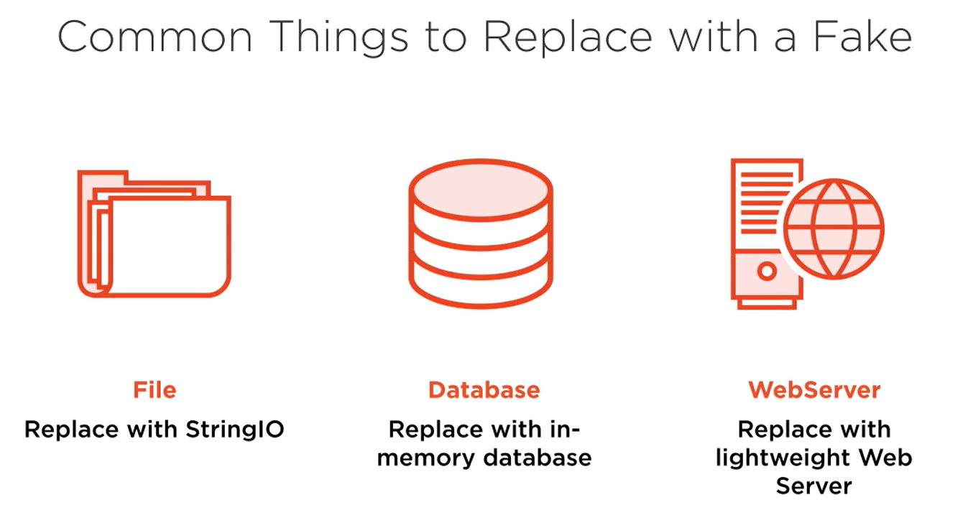

### Dummy

You use a dummy when you are forced to pass an argument to the method or function on the test, but that collaborator isn’t used in the scenario you are testing.

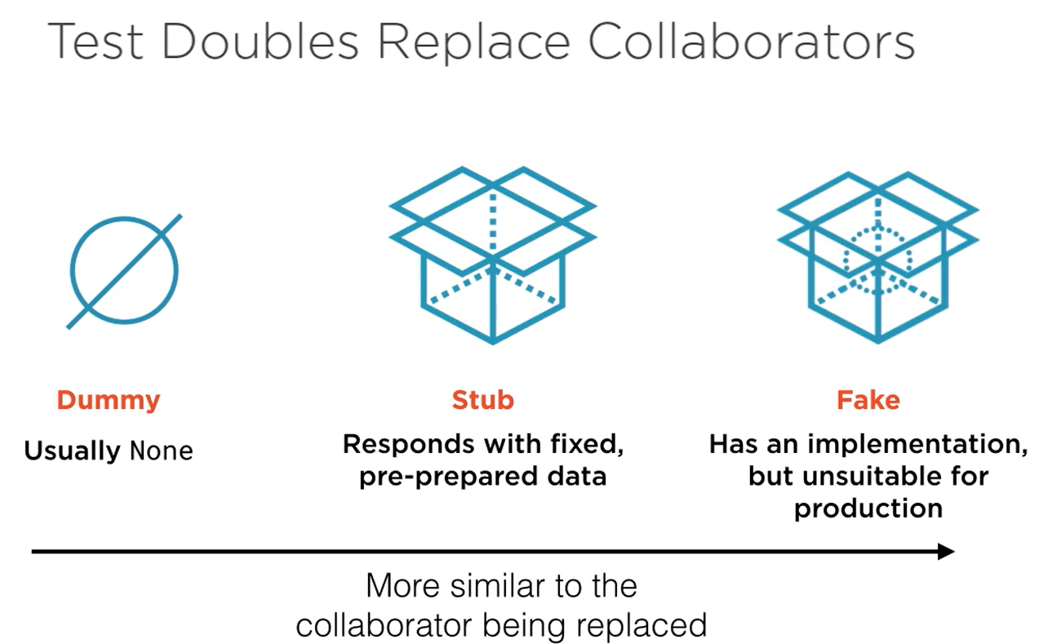

### Spies

Spy acts exactly like spy. Verifies if a method was called in another method that is being tested.

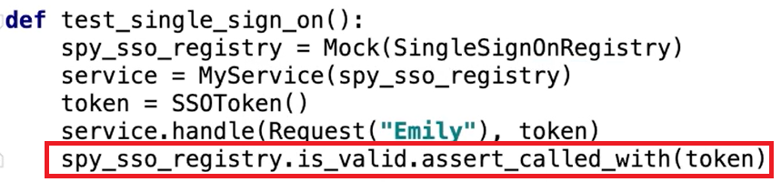

Here, we are trying to testing the method handle but we do want to make sure that the method is_valid is called with argument token while executing the handle method.

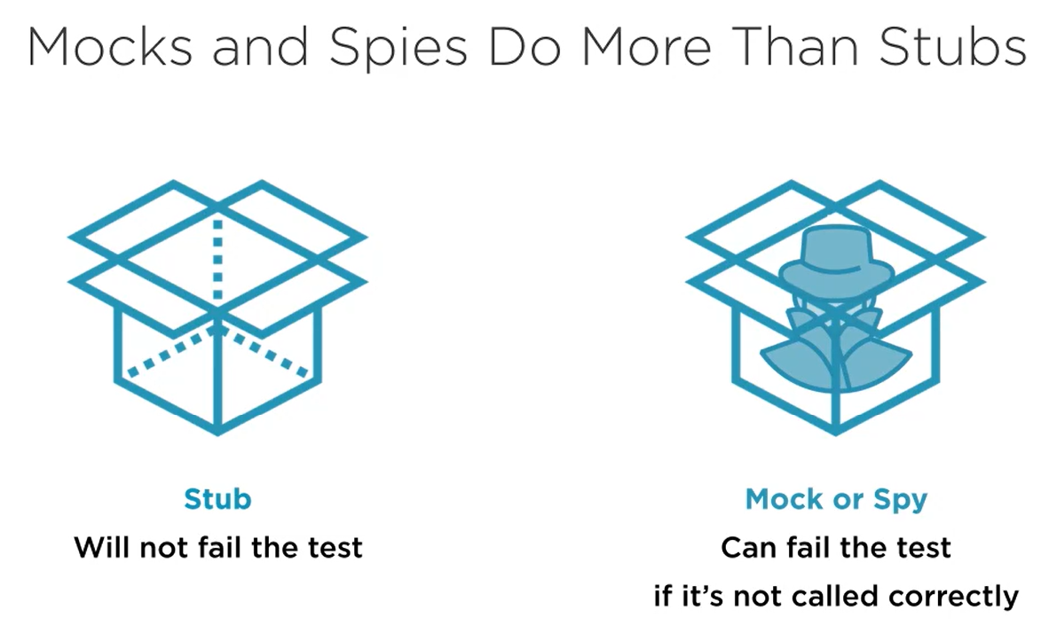

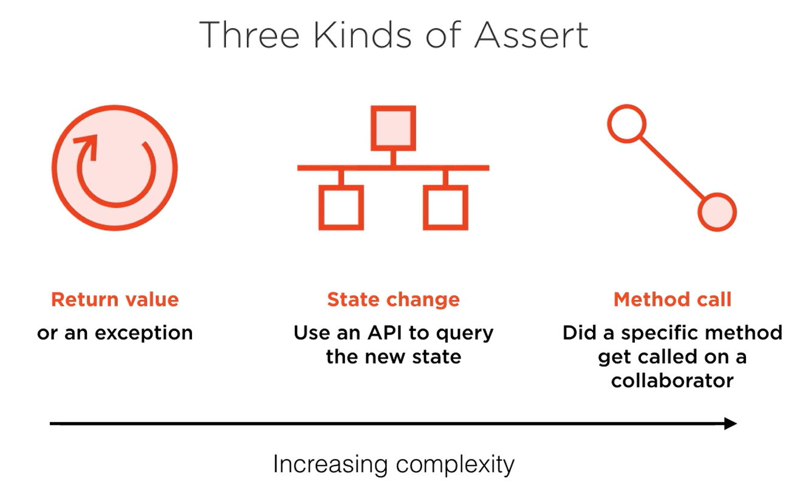

### Mocks

Mock is just like a spy but the main difference is that the mock has expectations about what method will be called and with what arguments and it will enforce those expectations as soon as it receives the wrong call. You don’t have to wait to the end of the test case like you do with a spy and interrogate it about what happens. It will blow up straight away.

So, you use a mock when you want to make sure that the interactions between two objects are happening correctly and you want the test to fail fast, as soon as any incorrect interaction happens, and that gives you a nice stack trace leading right back to where the incorrect call was made.

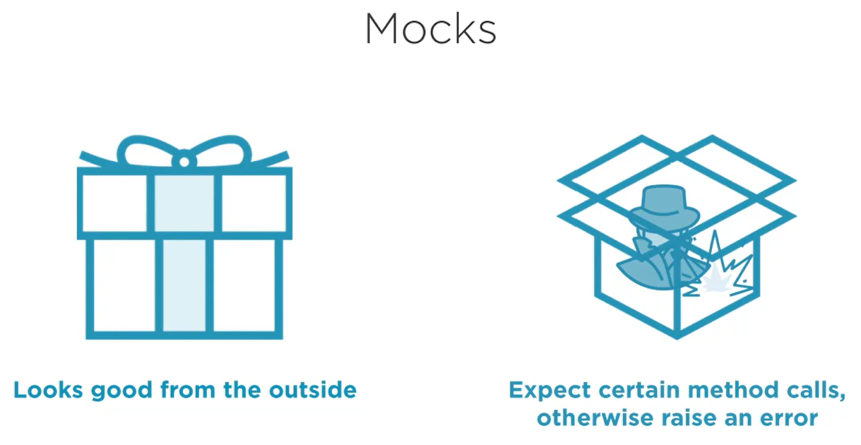

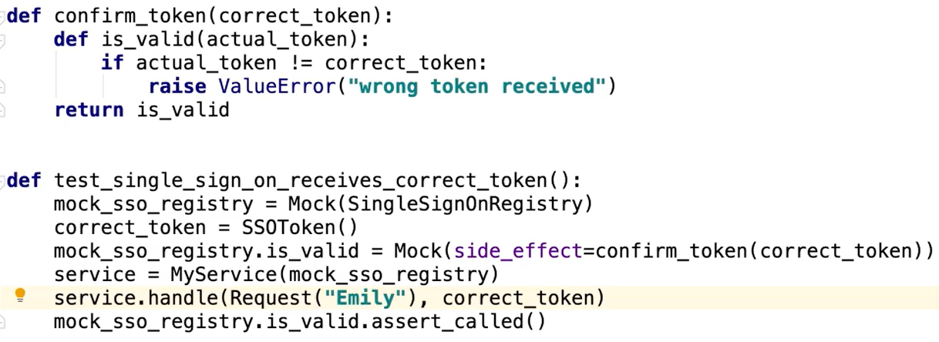

### Monkeypatching

Used to inject test doubles if there isn’t an easy way to do it.

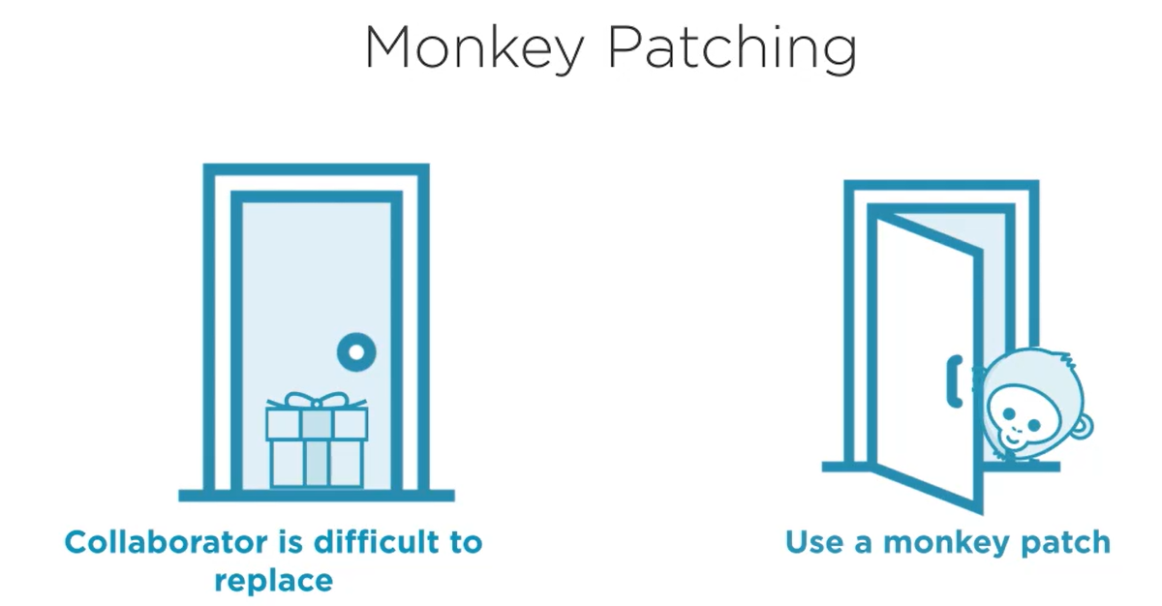

Refer TirePressure/test_alarm.py

## Parameterized Tests & Test Coverage

### Parameterized Tests

Refer folder ParameterizedTennis

* Helps to reduce the number of tests that you write
* When you have the same test code for multiple test functions with only slight parameters varying, use parameterized test to account for that difference
* Annotation to be used: @pytest.mark.parametrize(“<parameter>”, [<possible_values>])

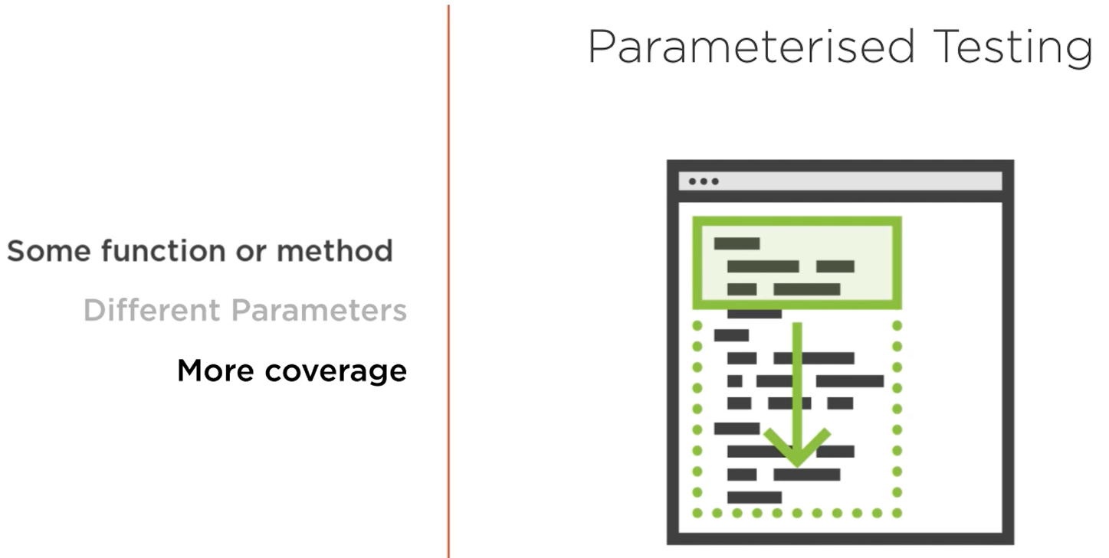

Parametrized Test with pytest

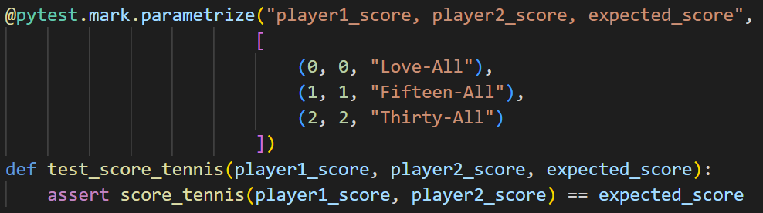

Parametrized Test with unittest

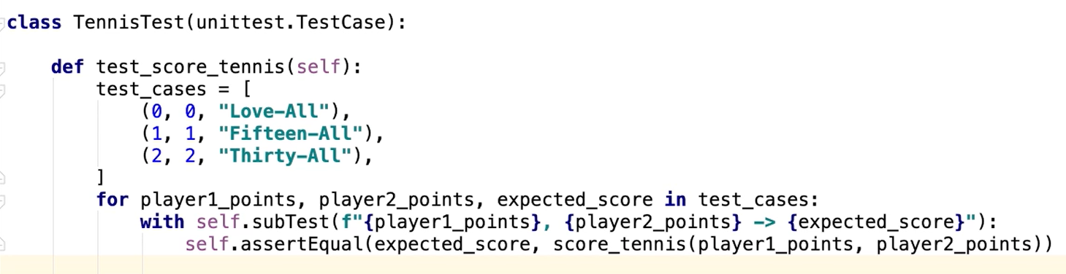

### Test Coverage

* Two packages required:
  + coverage
  + pytest-cov
* Run the following command:
  + coverage run -m pytest
  + coverage html

or

* + pytest --cov-report html:cov_html --cov-branch --cov=<module> <folder>

example:



* You will see a folder named **htmlcov**, open the **index.html** file inside it in a web browser
* Note: the branch coverage gives you more detailed report which we see in the last command shown in screenshot
* The percentage will go down only if some line of code is not covered by any of the test
* Having 100% code coverage does not mean that your code is perfect or that your tests are perfect

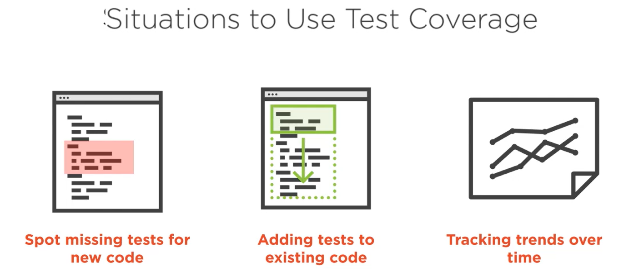

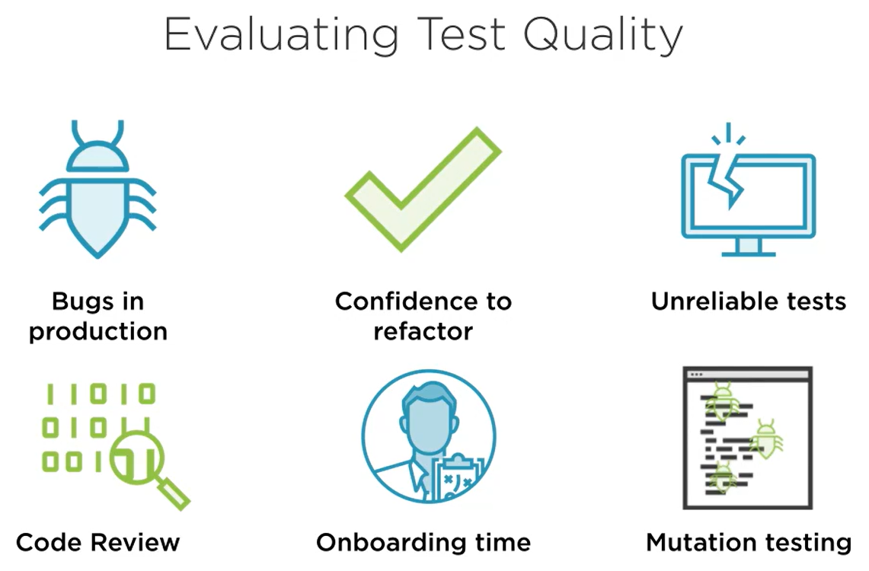

# Managing Python Packages & Virtual Environments

## Where are packages installed

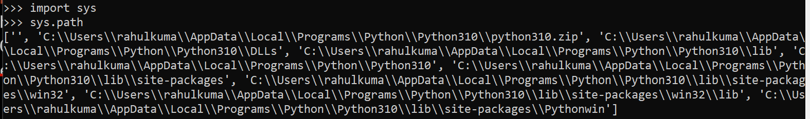

Installed in either of the directories listed in above screenshot.

Better way to find where a package is installed:

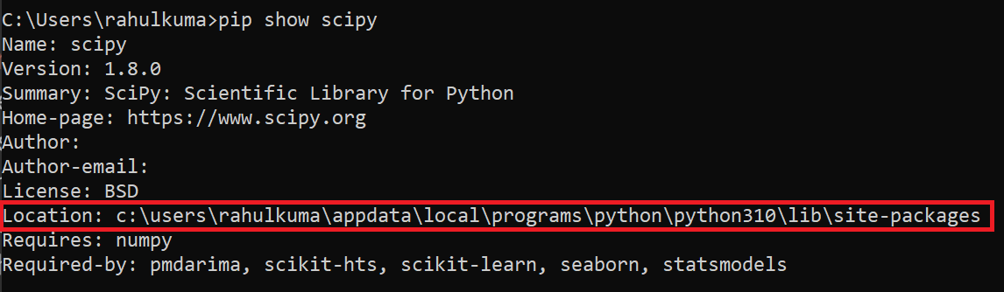

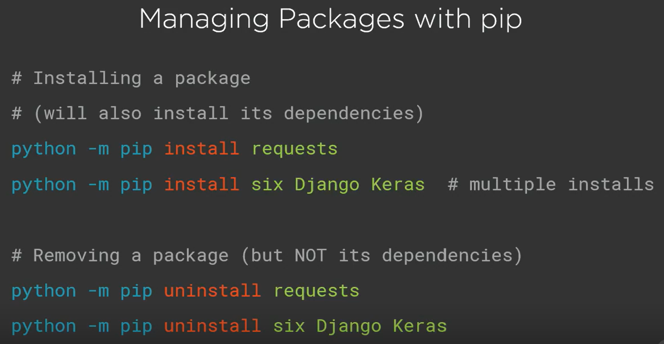

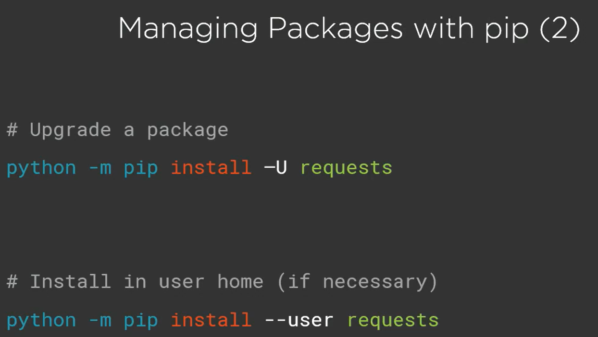

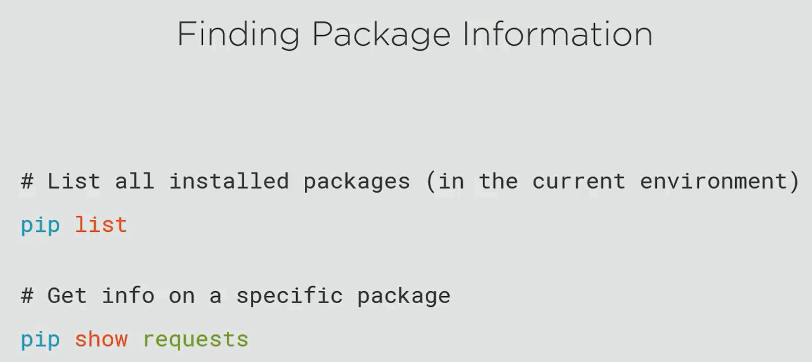

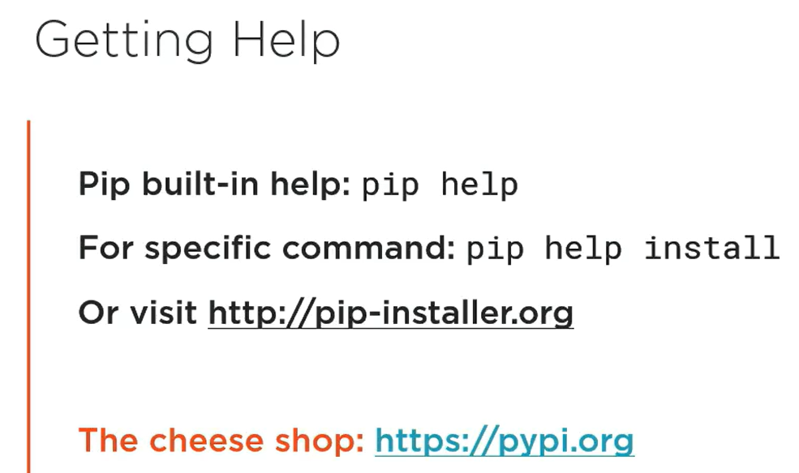

## Virtual Environments

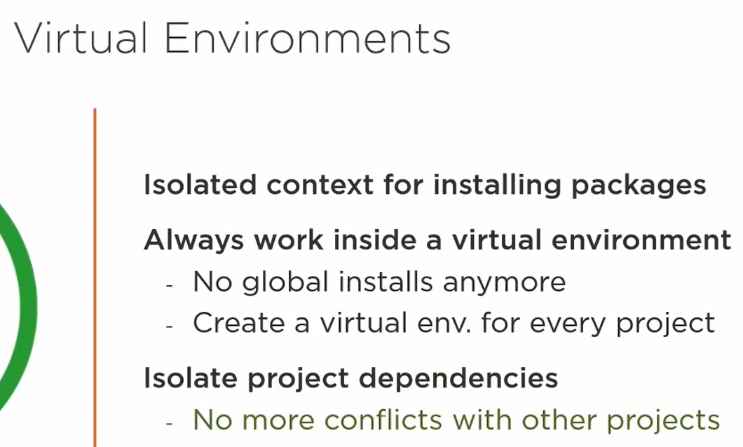

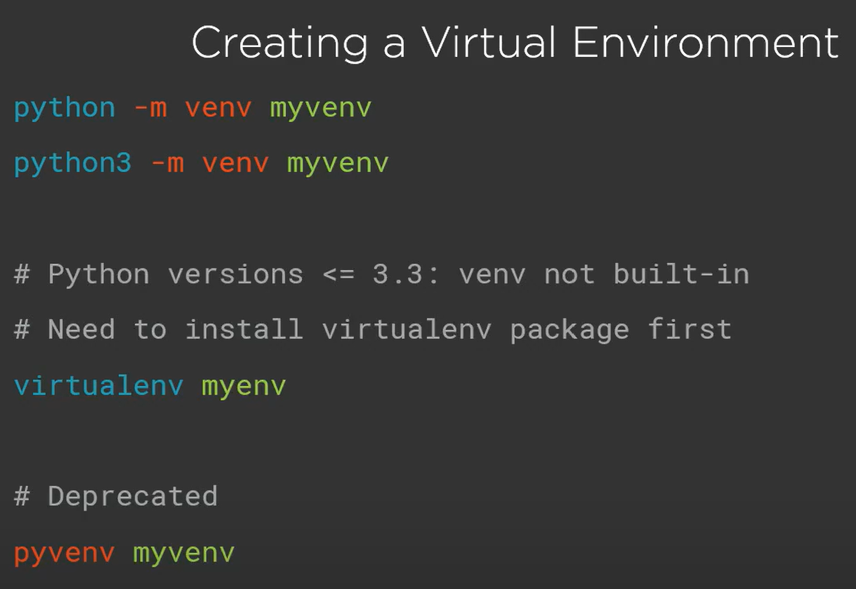

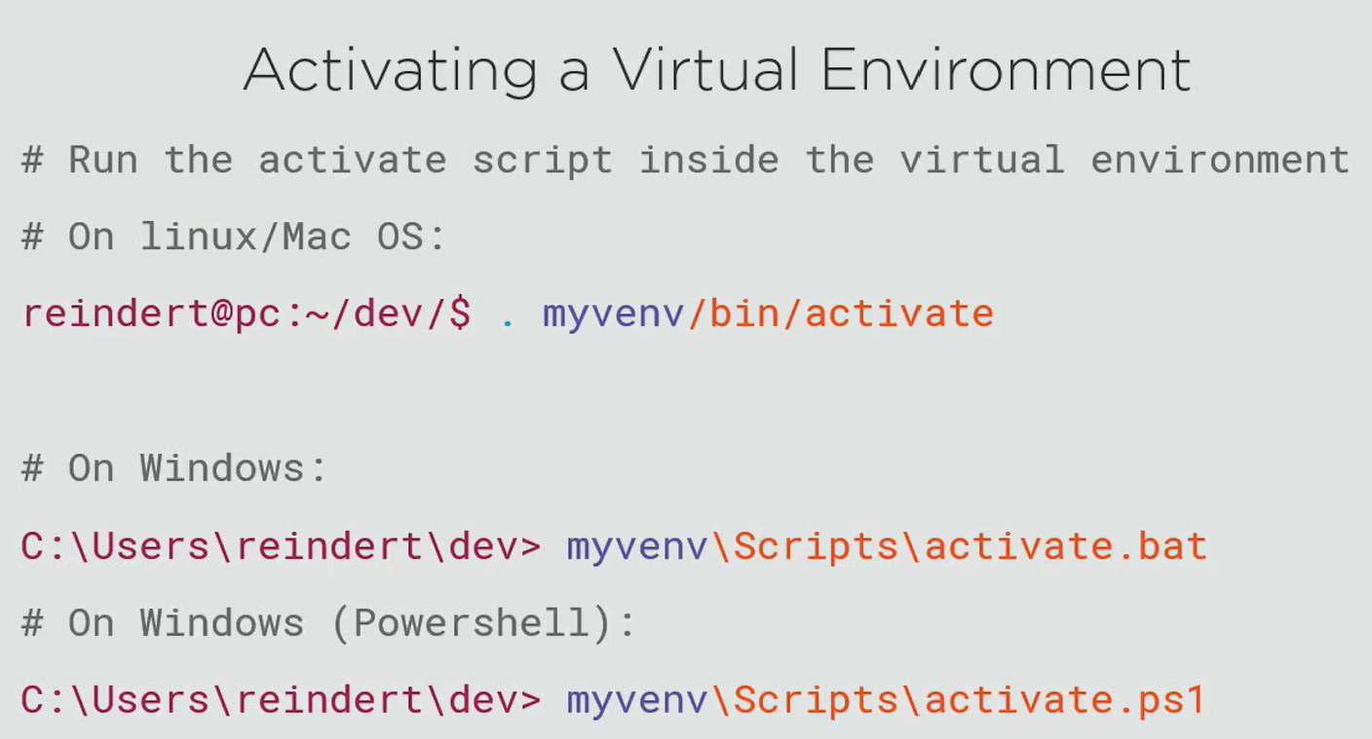

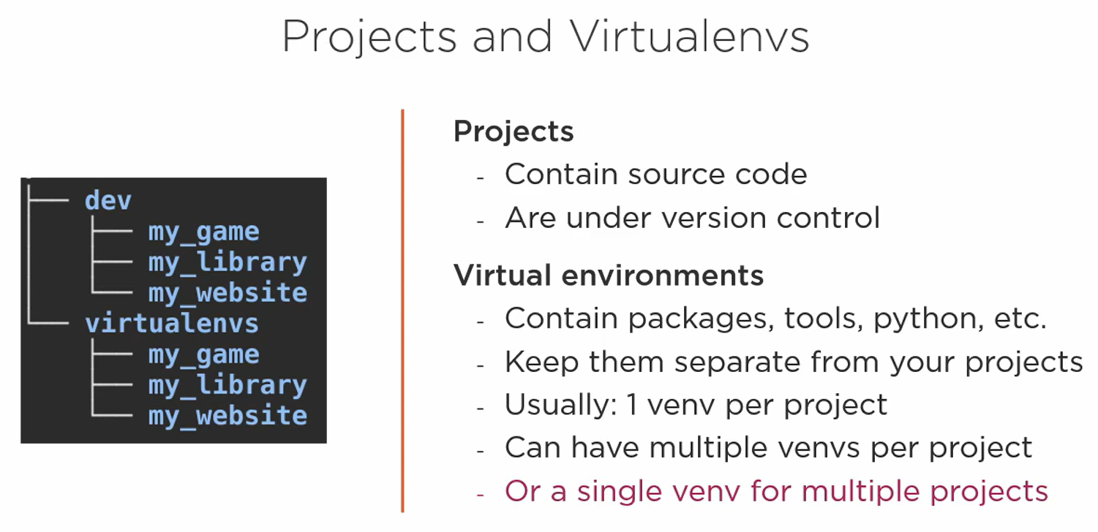

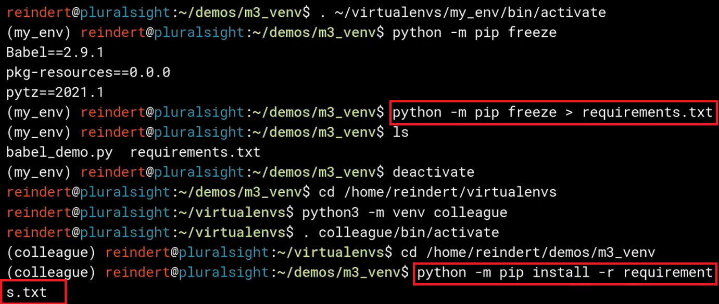

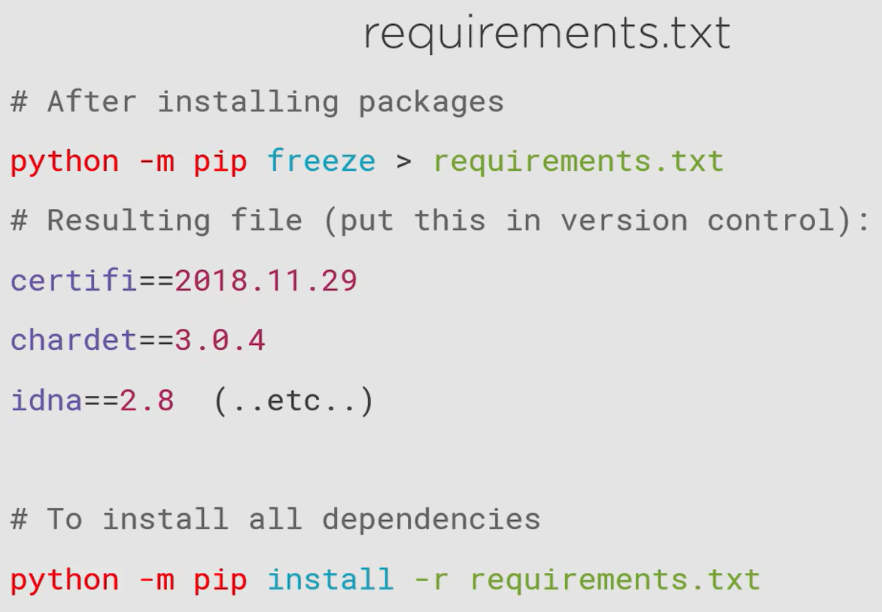

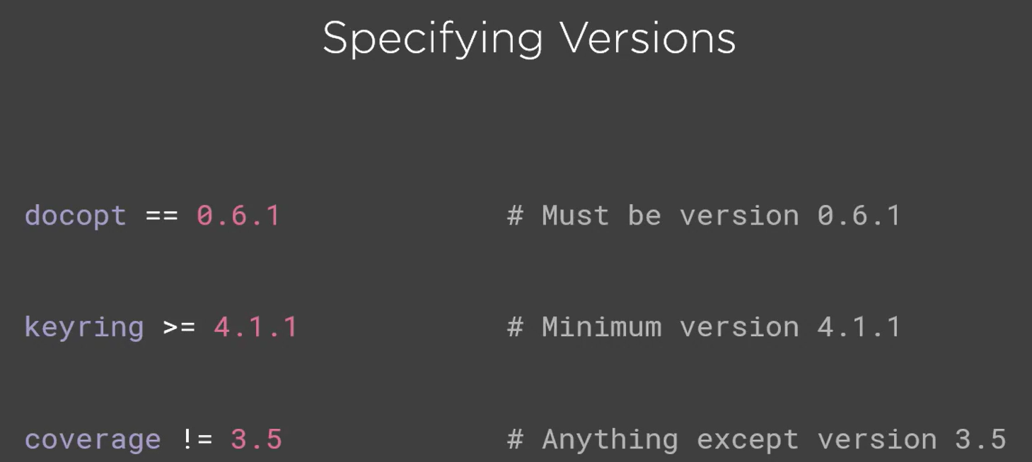

pip will install the latest version of a package that satisfies the condition.

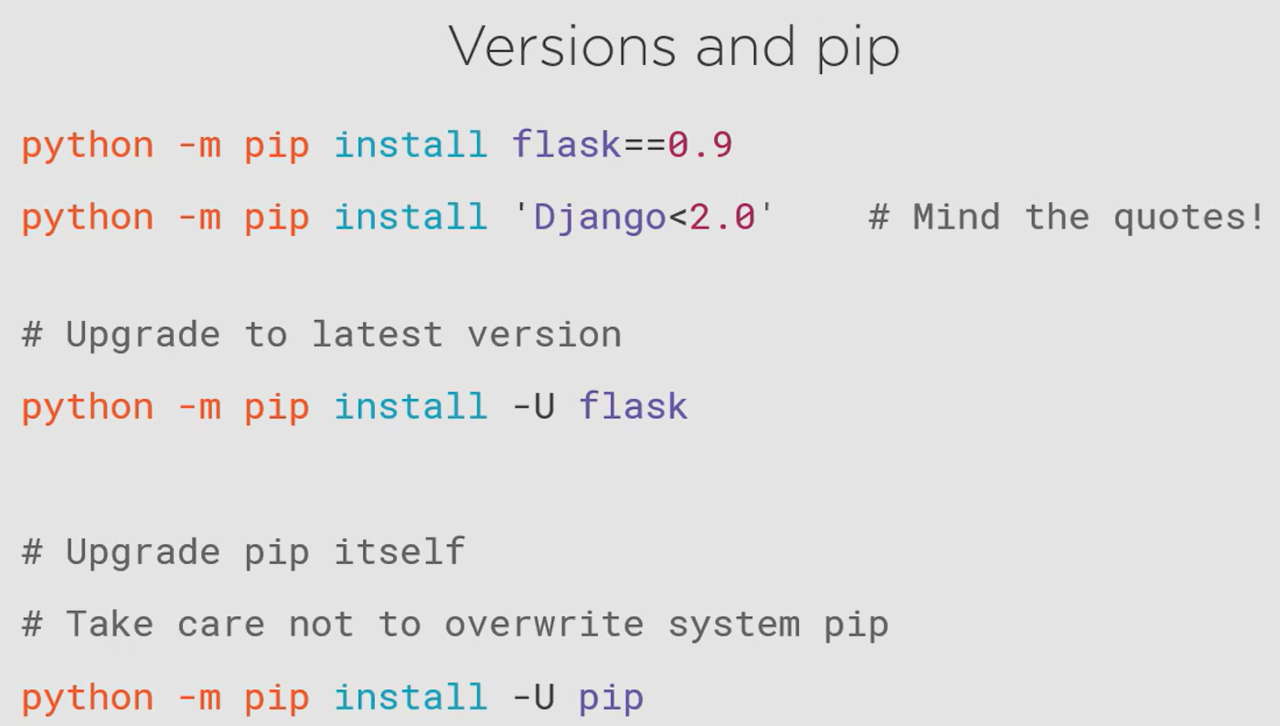

## virtualenvwrapper

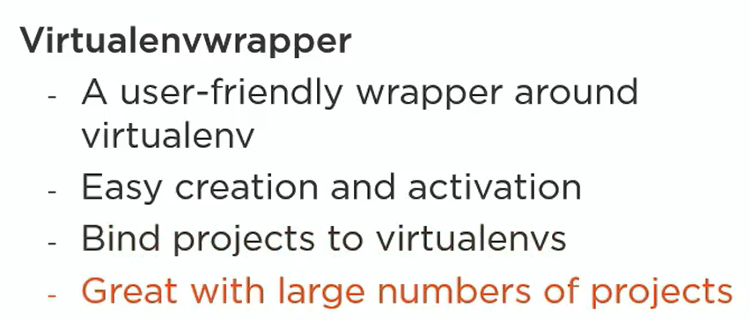

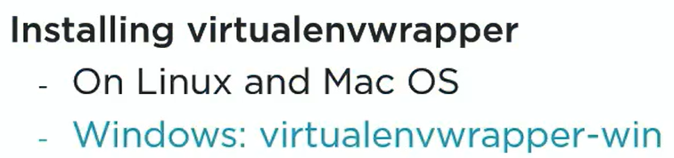

This is one of the packages that must be installed system wide and not in any specific virtual environments as this des not belong to one. This will be used to manage virtual environments.

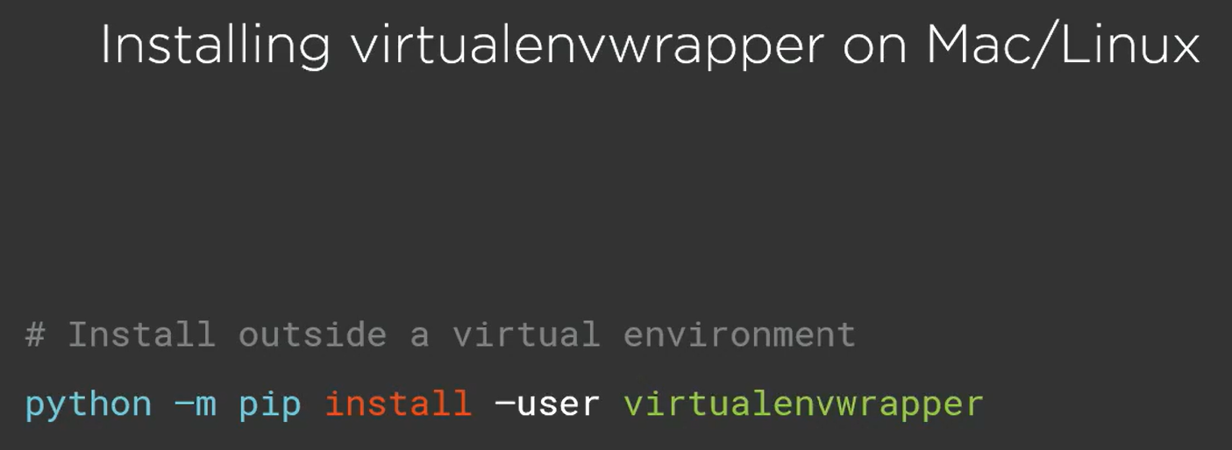

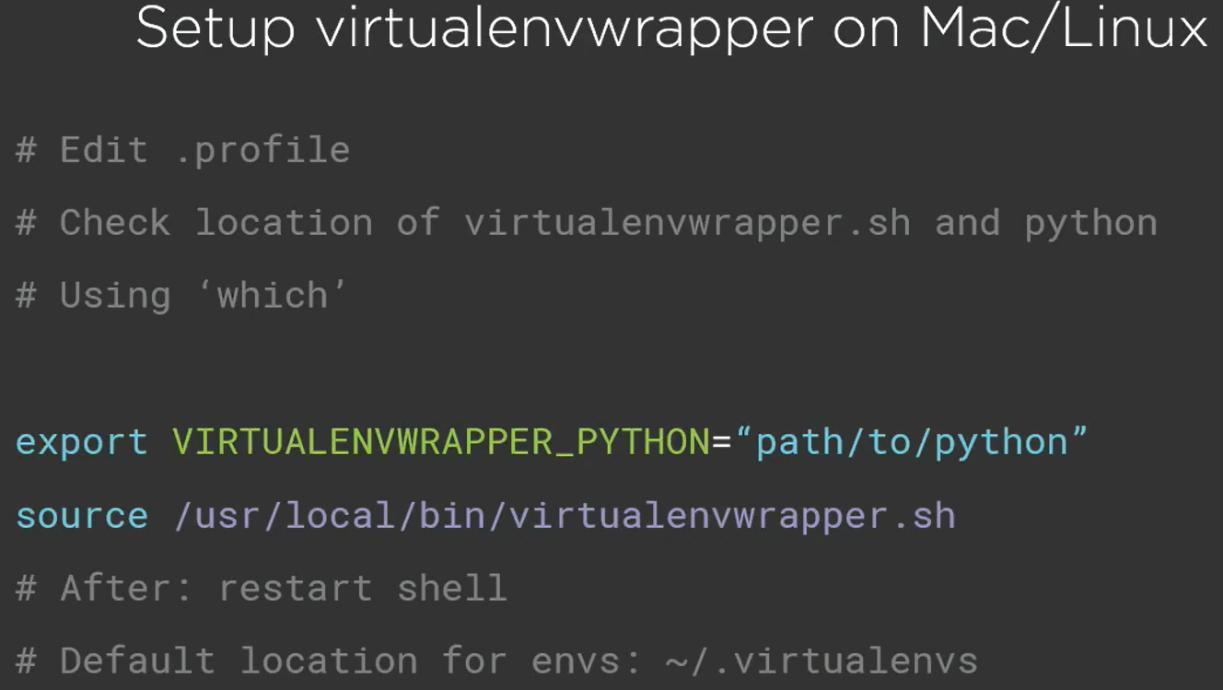

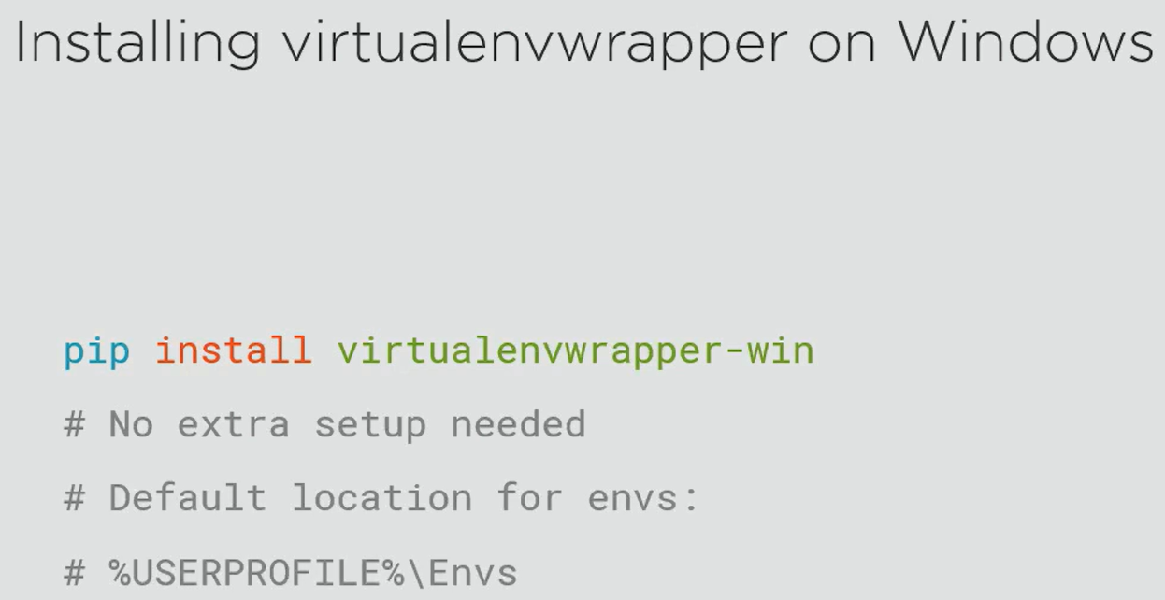

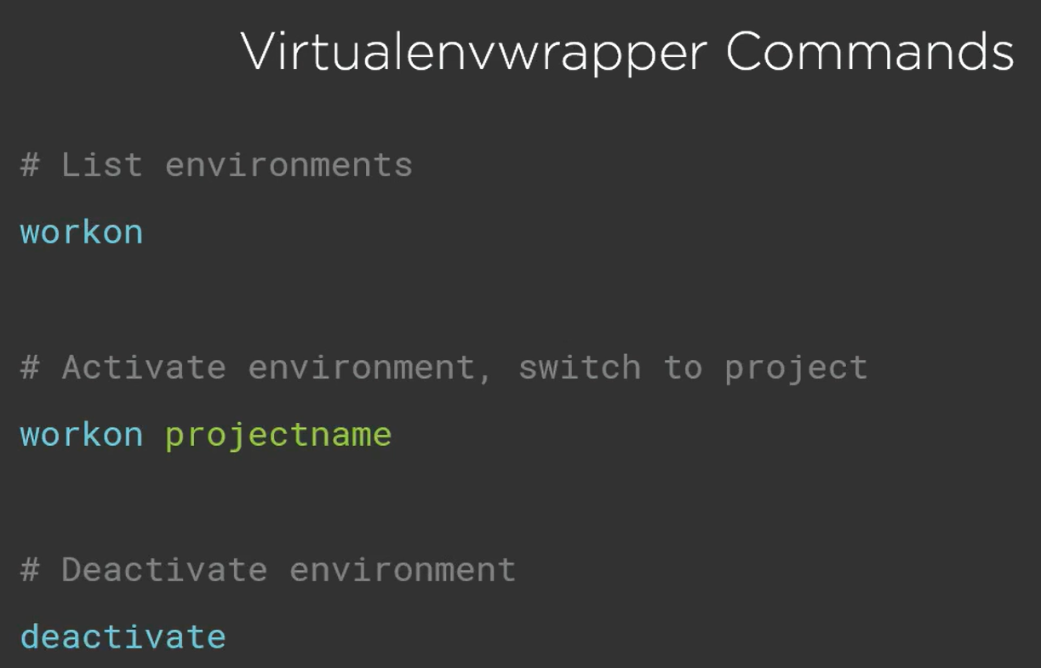

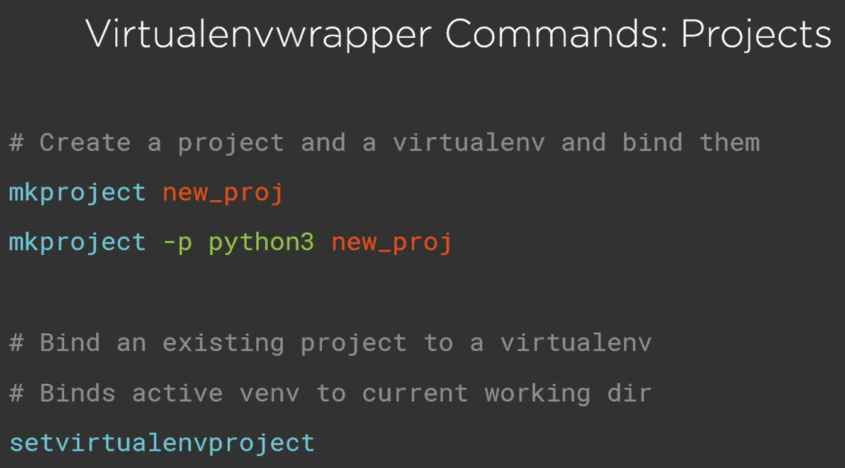

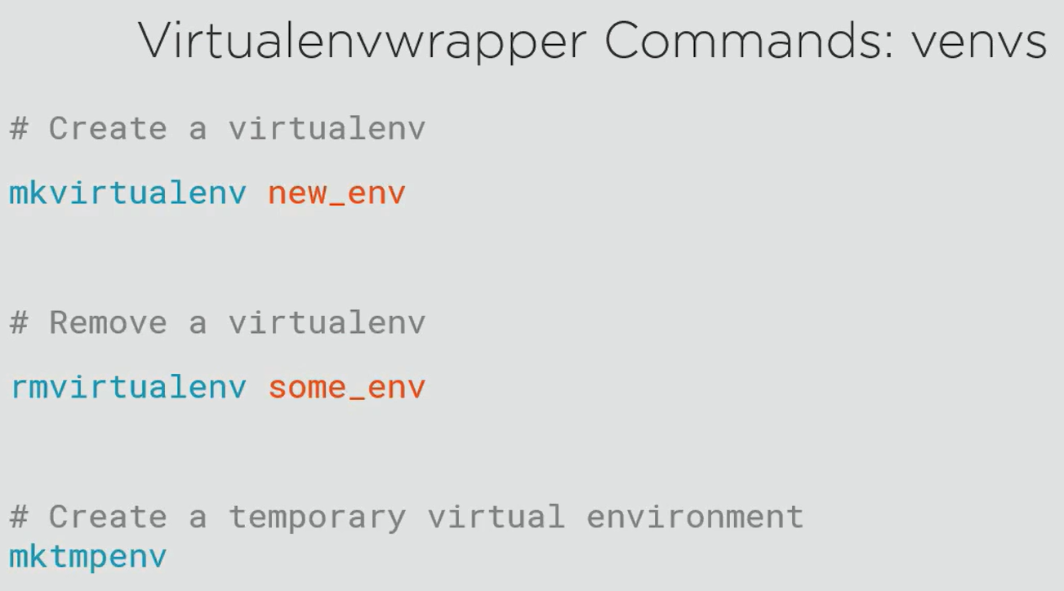

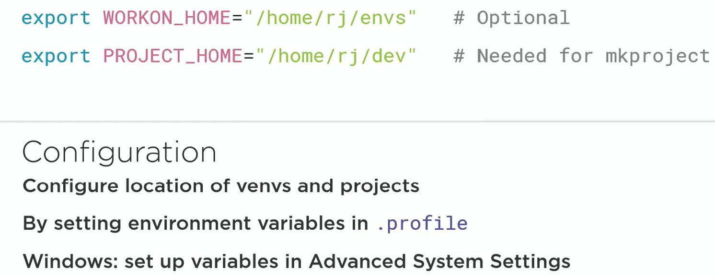

## Choosing the right tools

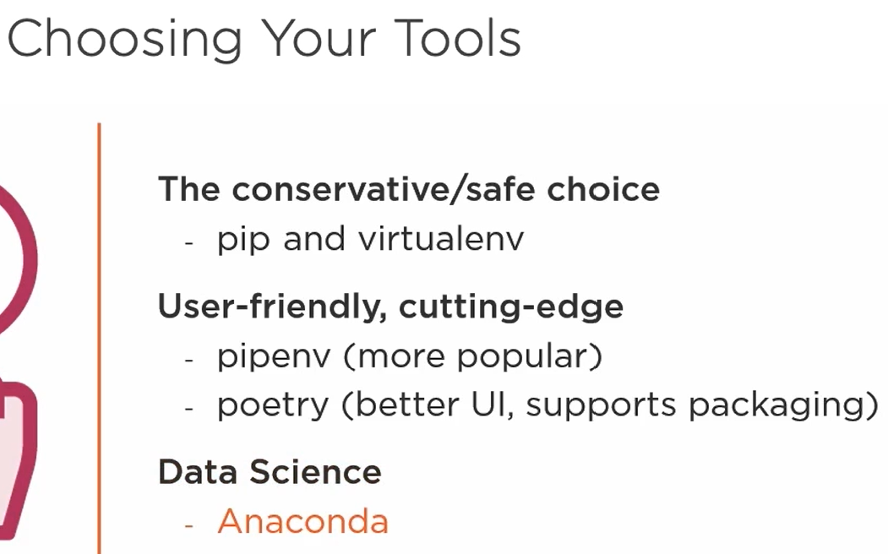

# Python Best Practices for Code Quality

## Python Style Guidelines: PEP8 and Pylint

### PEP8

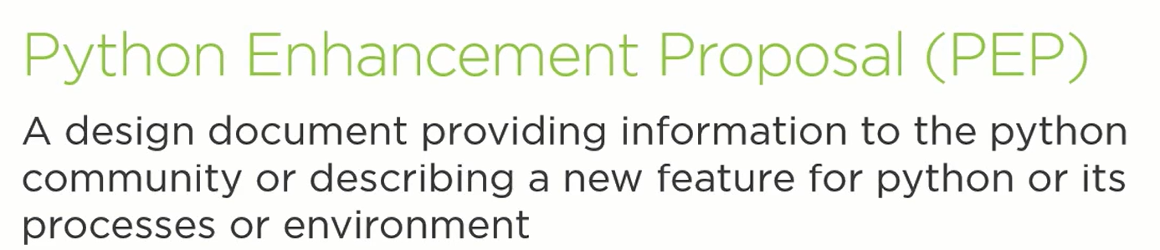

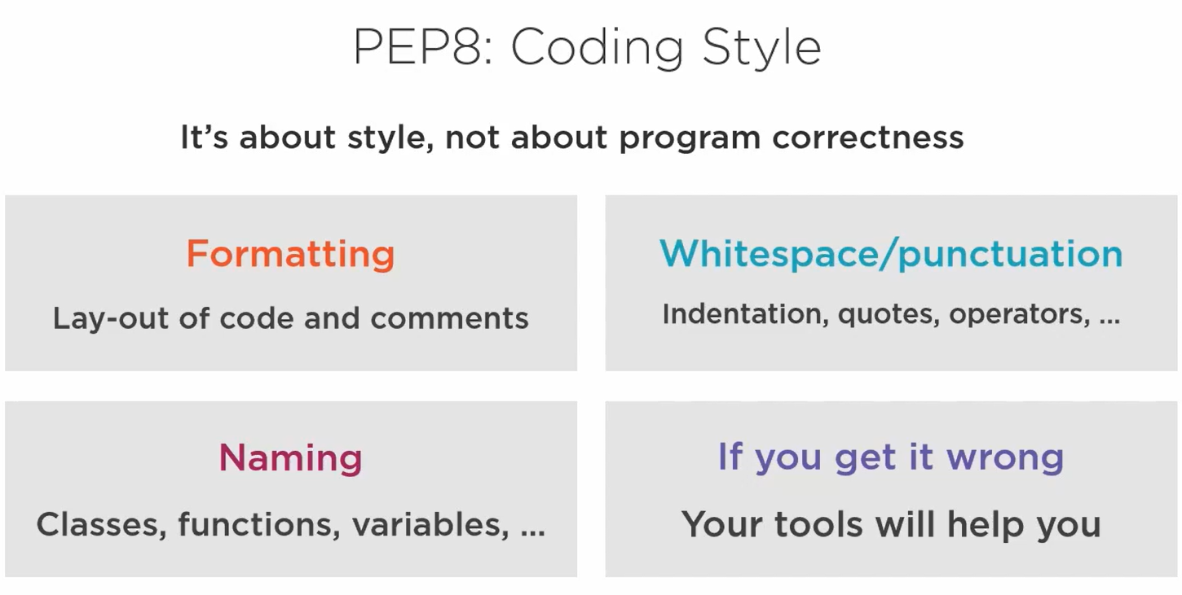

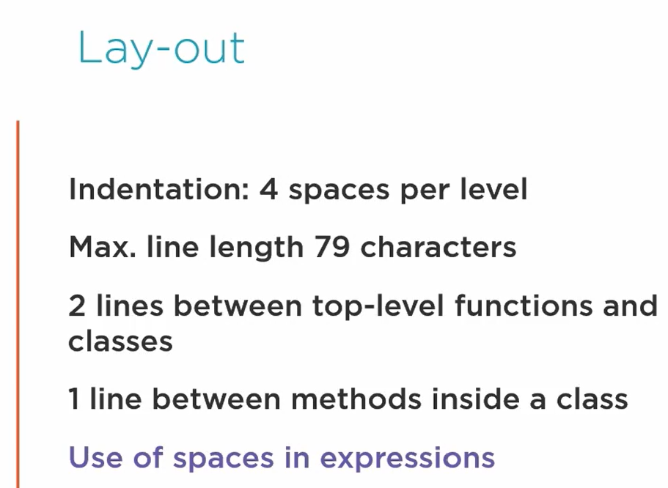

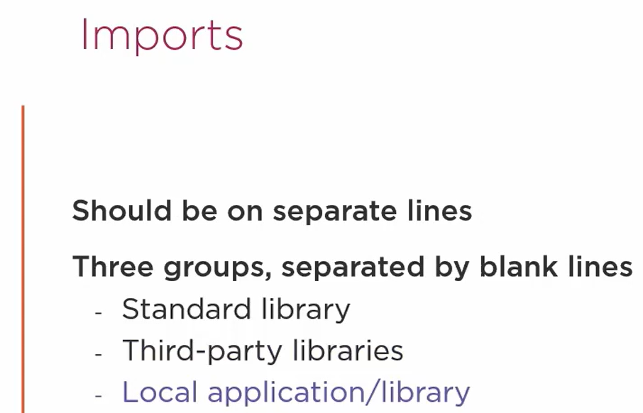

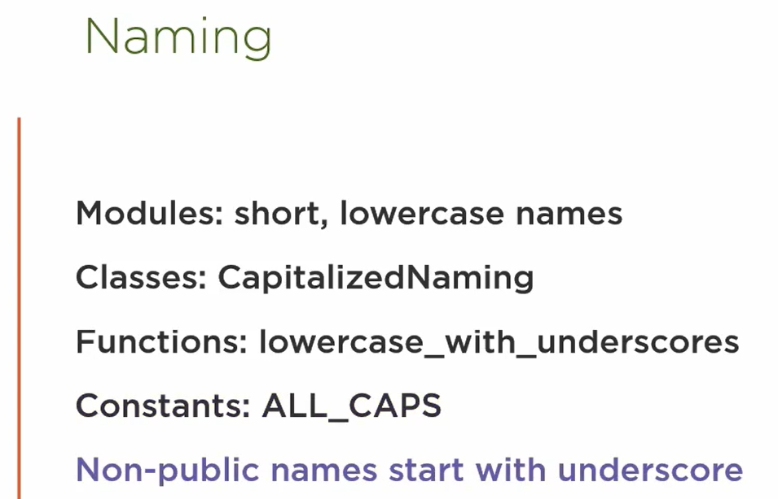

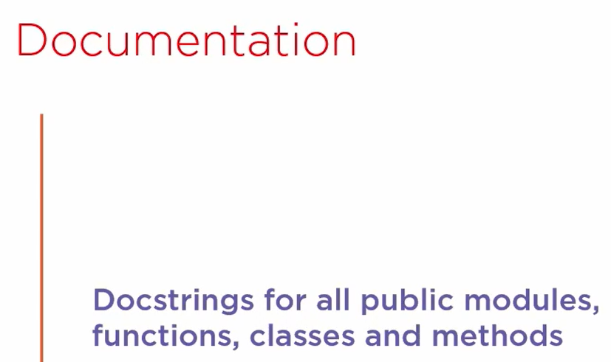

### Other Tools

* **pylint**
* Install the package pylint using pip
* Note that it evaluates based on PEP8 + additional guidelines
* Run the following command to check code quality:
  + pylint <folder_or_filename_with_extension>
* How can I decide which warnings I want to see (customize code style)?
  + Run the following command to generate rc file
    - pylint --generate-rcfile > pylintrc
  + Make changes in the pylintrc file and save it
  + Run the pylint command to check code quality (it is customized and you will see warnings based on your customization)
* **pycodestyle**
  + Install the package pycodestyle using pip
  + Note that it evaluates based on PEP8 only
  + Run the following command to check code quality:
    - pycodestyle <folder_or_filename_with_extension>
  + Only shows PEP8 warnings
  + Less popular than pylint
* **black**
* Install the package black using pip
* Run the following command to fix PEP8 code quality warnings:
  + black <folder_or_filename_with_extension>
* Run the pylint command to see all the PEP8 warnings have been fixed (there might be additional warnings still present which are not PEP8)

## Documenting your Project

### Docstrings

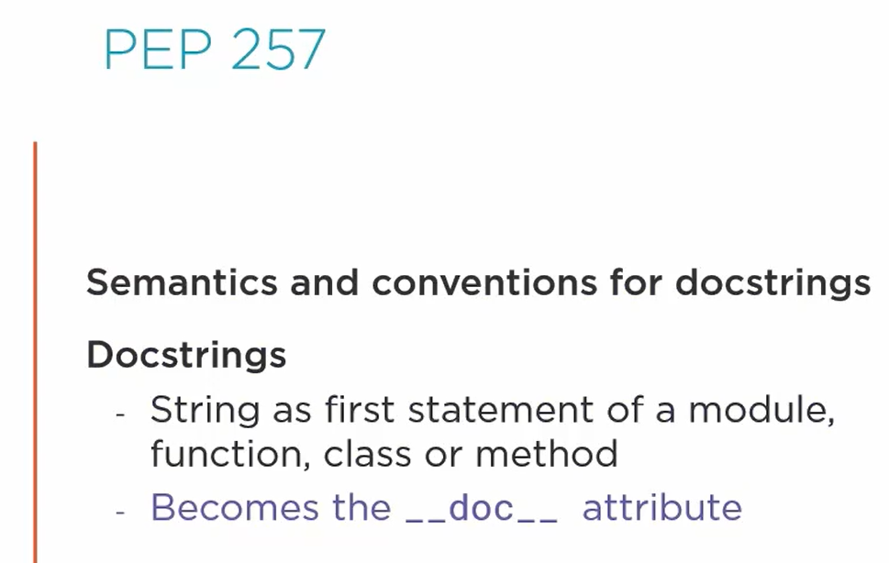

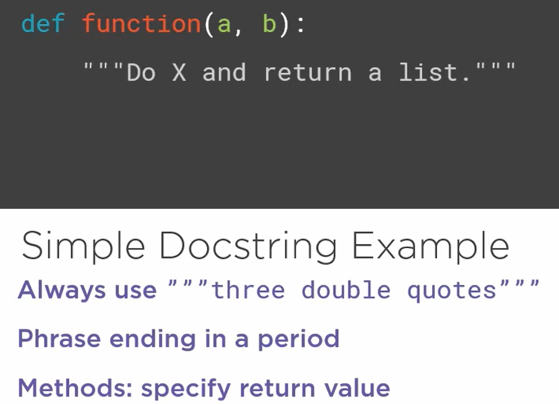

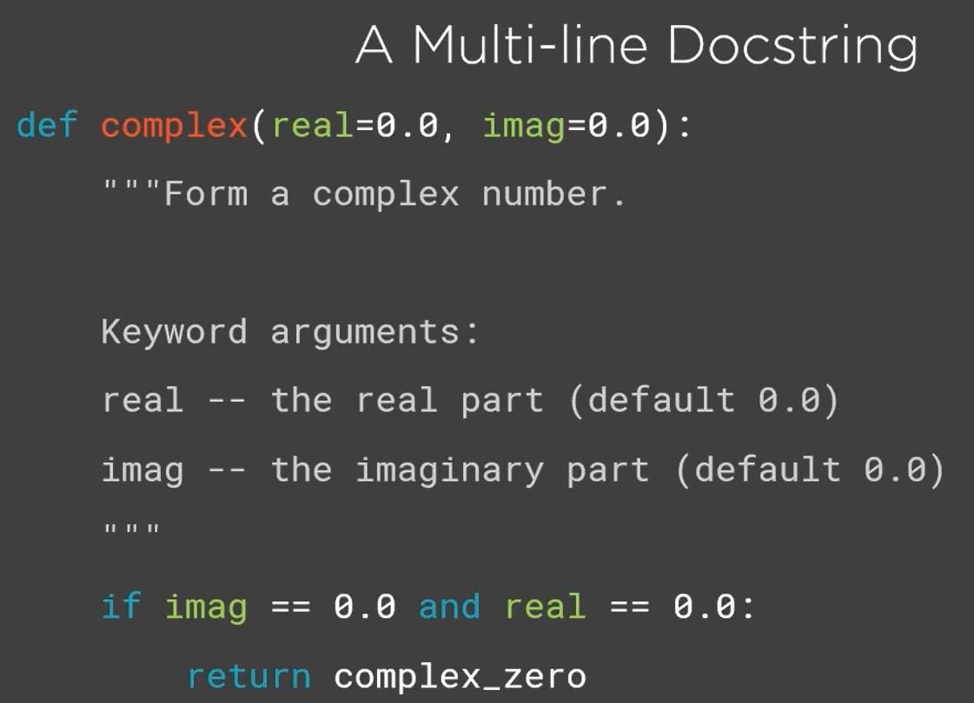

### Sphinx

* Need to install package sphinx using pip
* Move to the directory where you want to generate documentation
* Run the following command and fill in the details that are being asked:

sphinx-quickstart

* Configuration that you enter (details that you entered) are stored in conf.py which can be edited alter if required

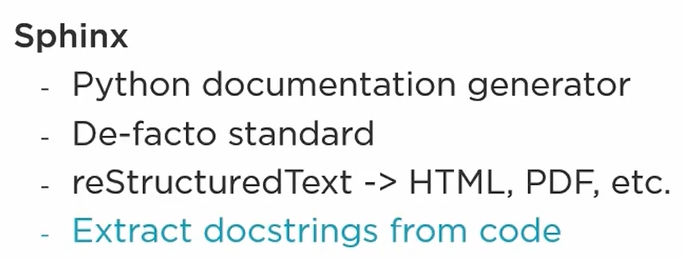

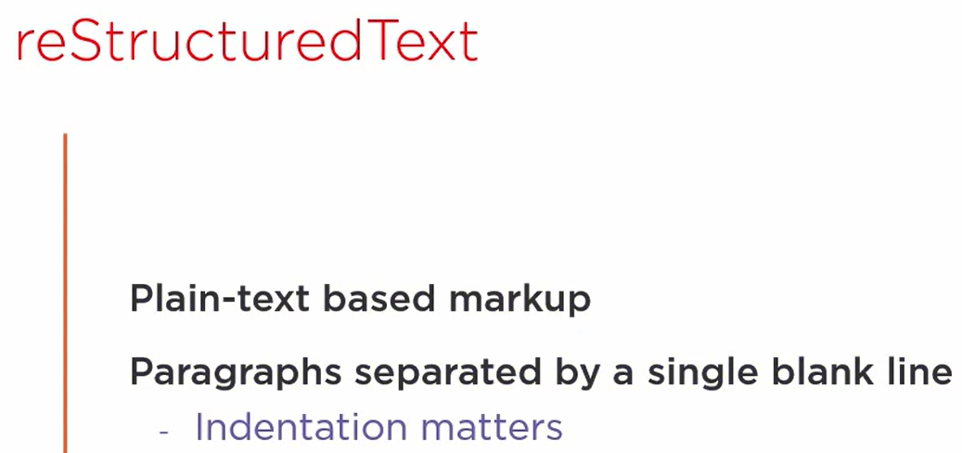

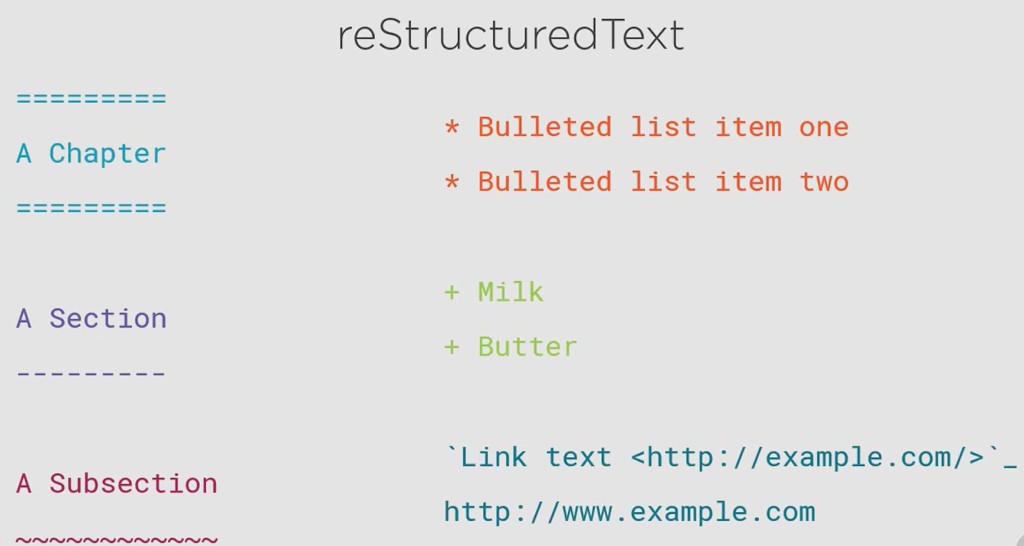

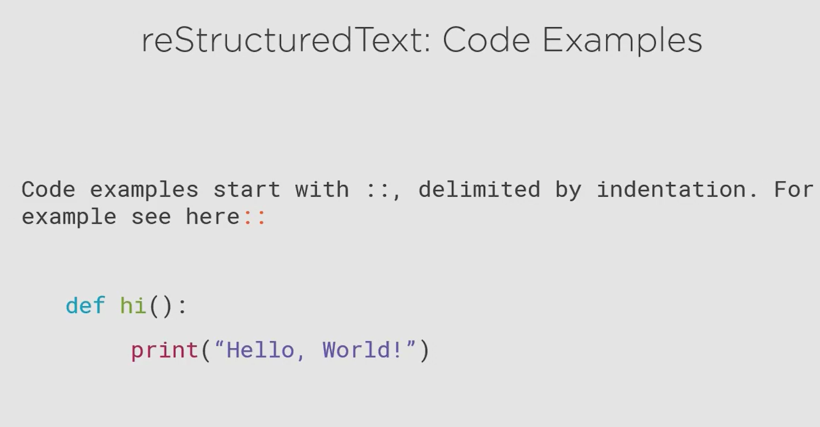

The block of code must have a blank line at the start and at the end.

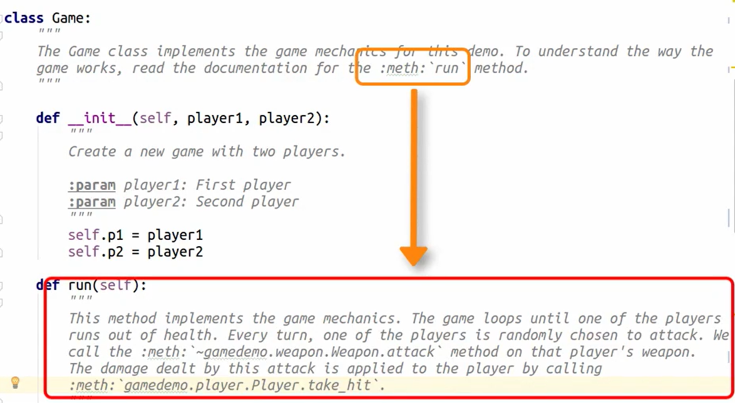

To auto generate documentation from code:

* Open the conf.py file and uncomment the following line

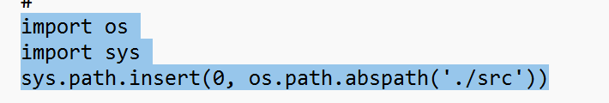

The last line contains a path which serves as the source, where the sphinx will look for code to generate documentation (configure it properly)

* In the same file, add the highlighted section

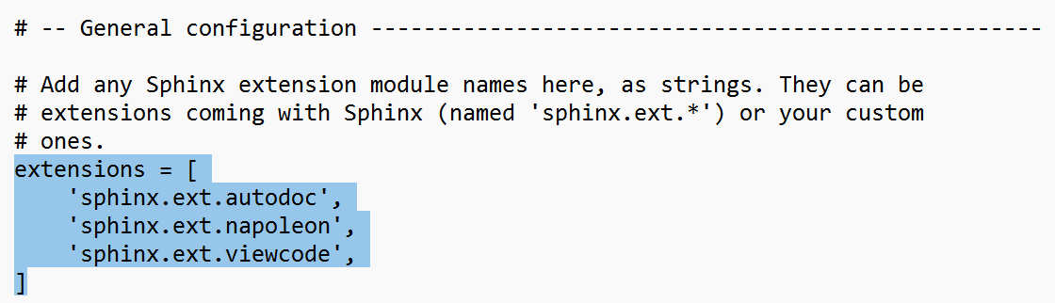

* Open cmd
* Run command **conda activate dev**
* Run command: **cd C:\`Dev\SphinxDoc**
* Make sure directory **C:\`Dev\SphinxDoc\out** is empty
* Copy the directory for which you want to generate doc to this directory: **C:\`Dev\SphinxDoc\src**
* Run the command **sphinx-apidoc -o ./out ./src**
* Run command **make clean**
* Run command **make html**
* Final HTML page can be found in **C:\`Dev\SphinxDoc\_build\html\out**

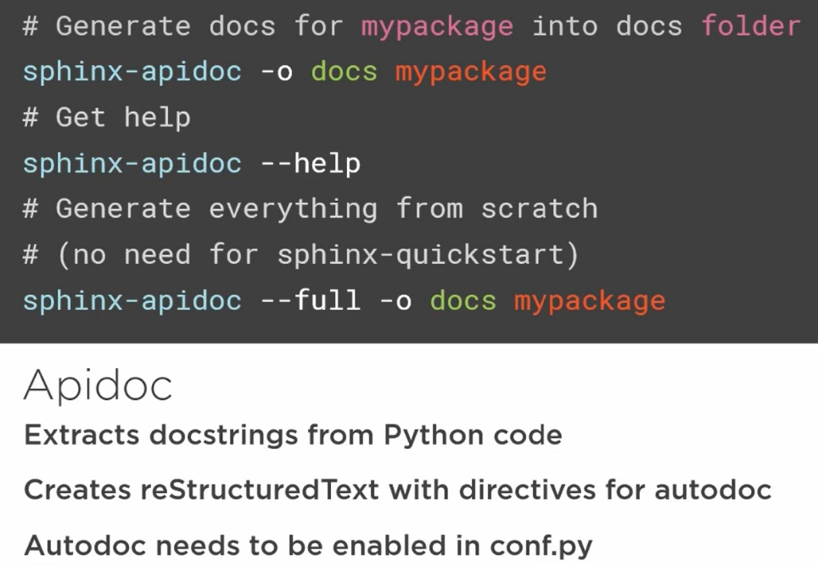

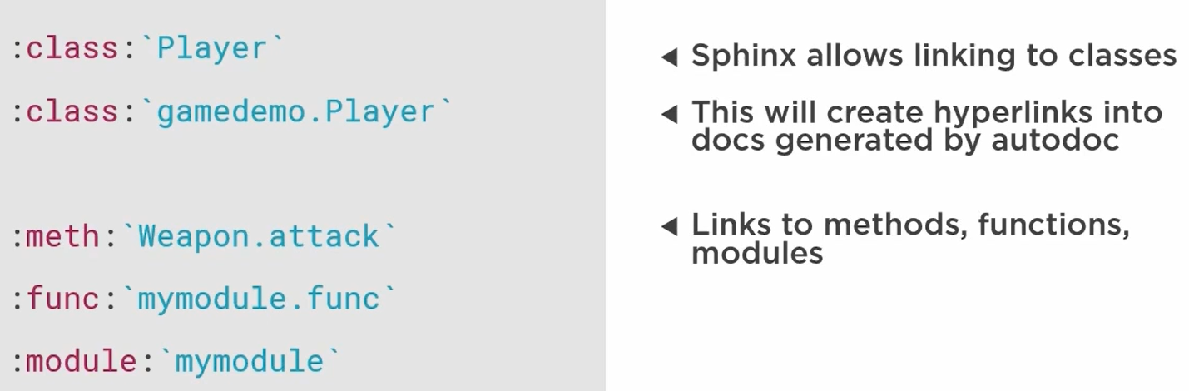

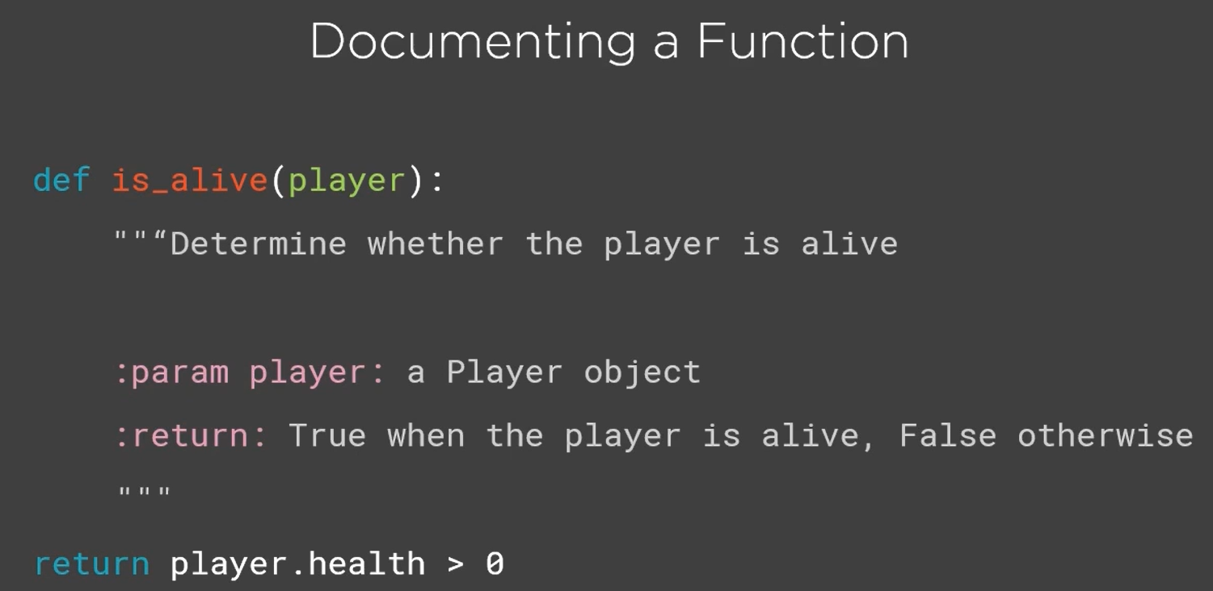

## Improve Code with Type Checking

### Type Checking

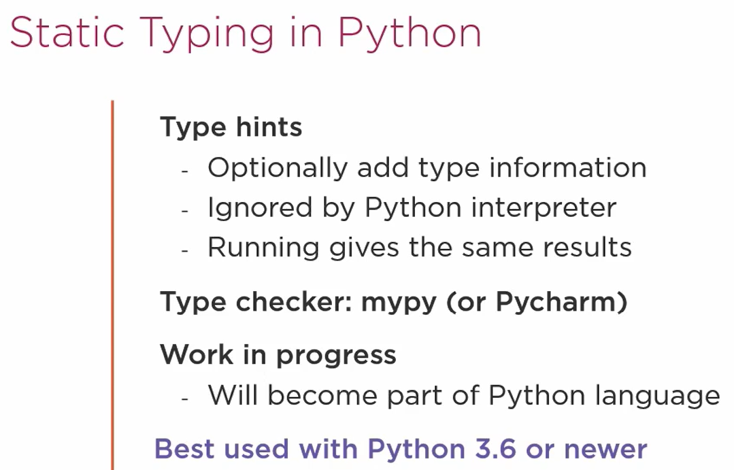

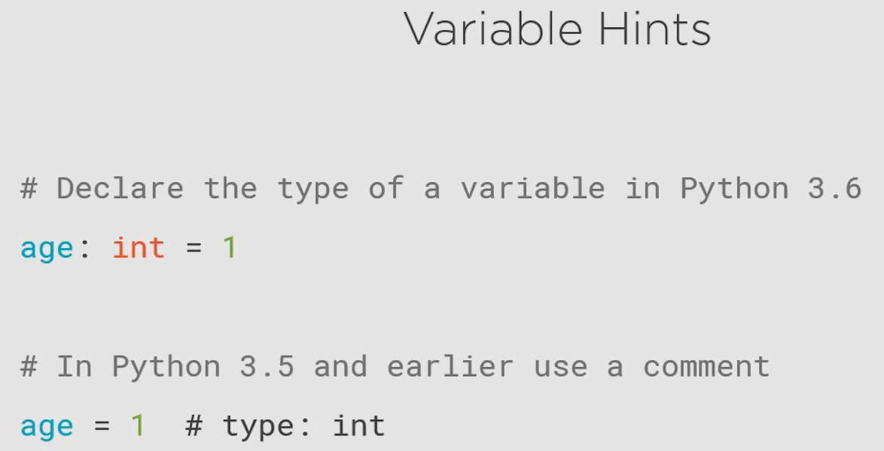

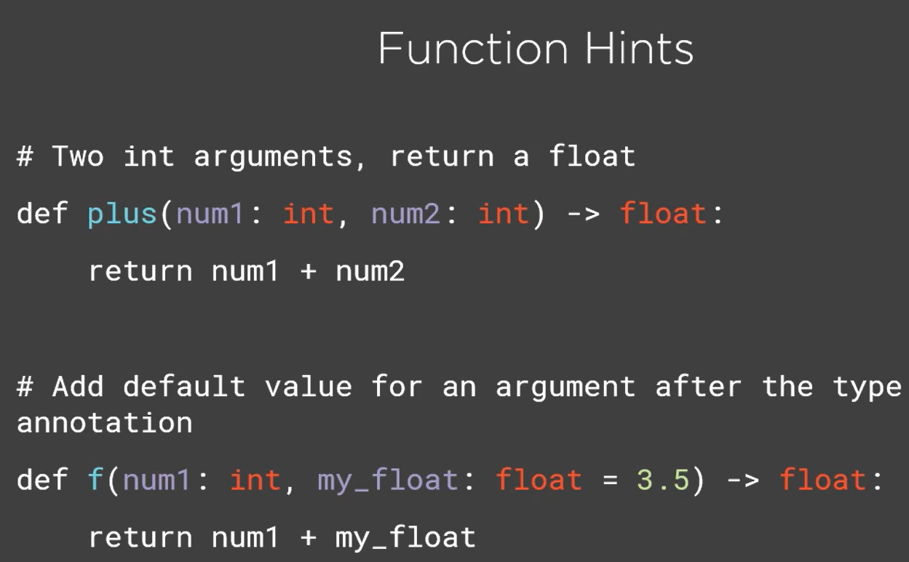

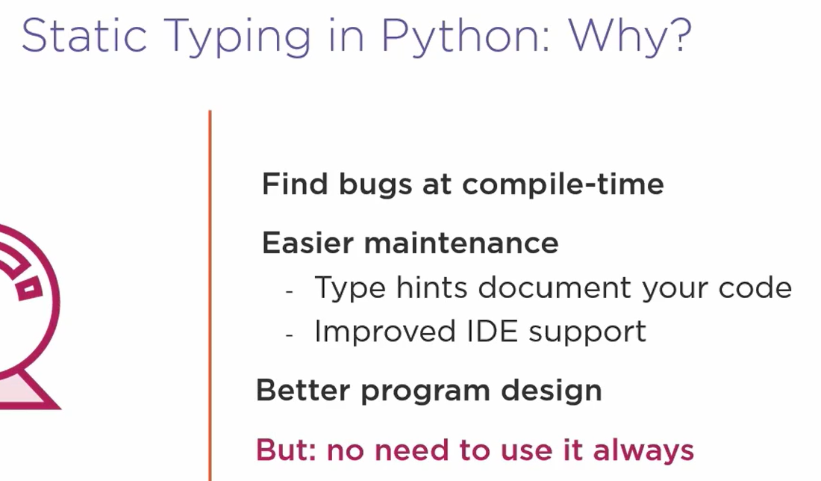

Refer [Type hints cheat sheet (Python 3) - mypy 0.961 documentation](https://mypy.readthedocs.io/en/stable/cheat_sheet_py3.html) for writing type hints.

### mypy

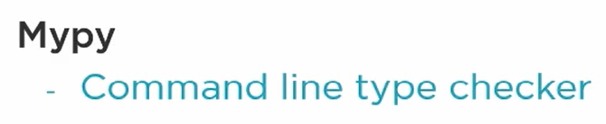

* Install the package mypy using pip
* Run the following command to perform type checking:
  + mypy <folder_or_filename_with_extension>

# Python Anti-patterns

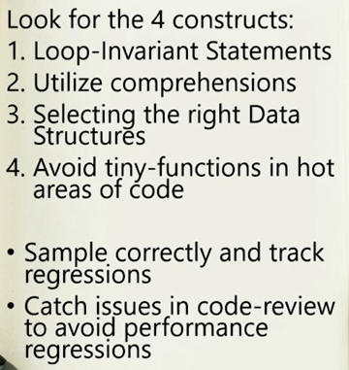

1. Loop Invariant

Avoid writing expressions that do not change in a loop, put it outside the loop

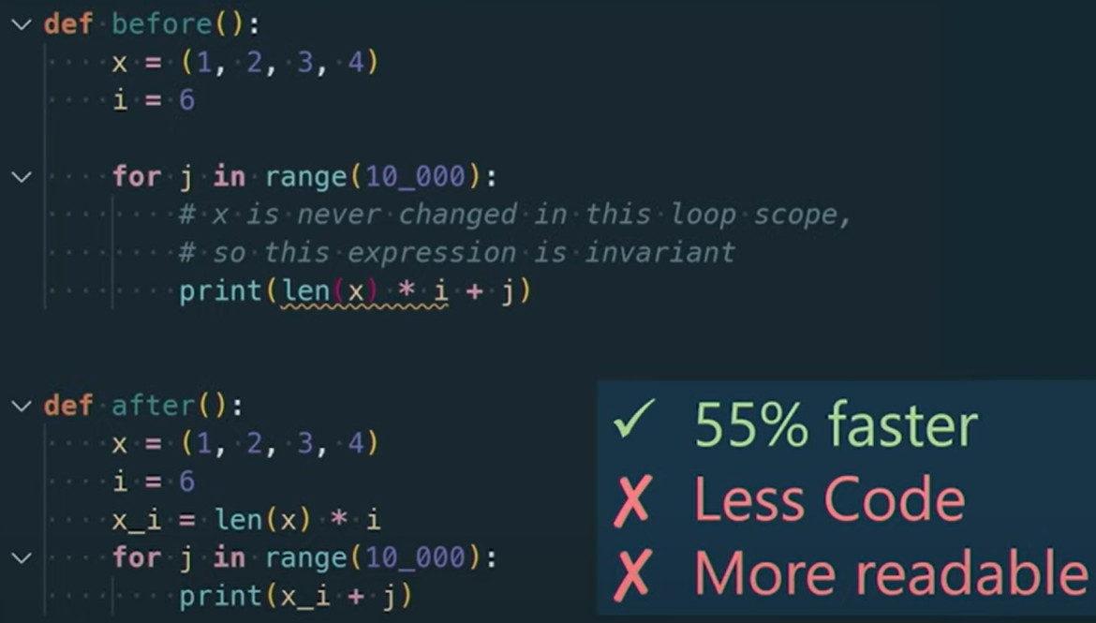

1. Utilize comprehensions

Make sure to utilize comprehensions whenever possible, they are faster.

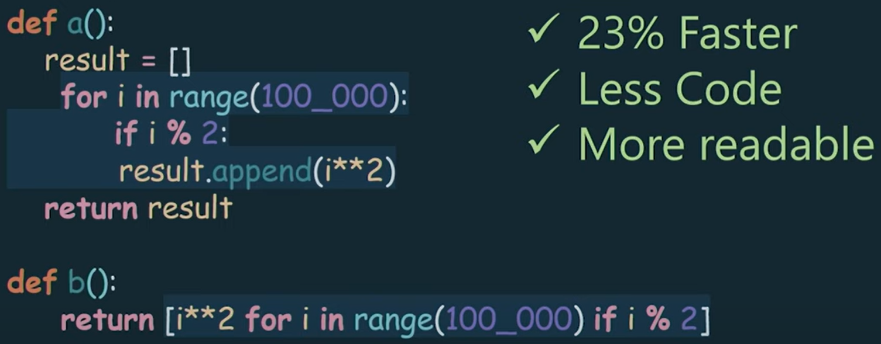

1. Select the right data structure

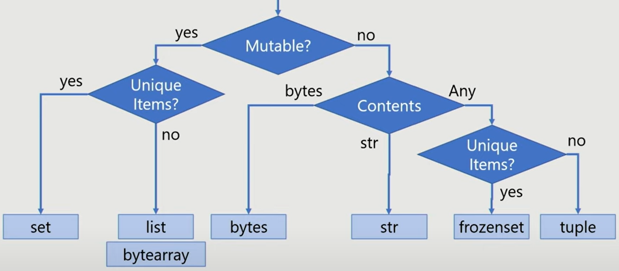

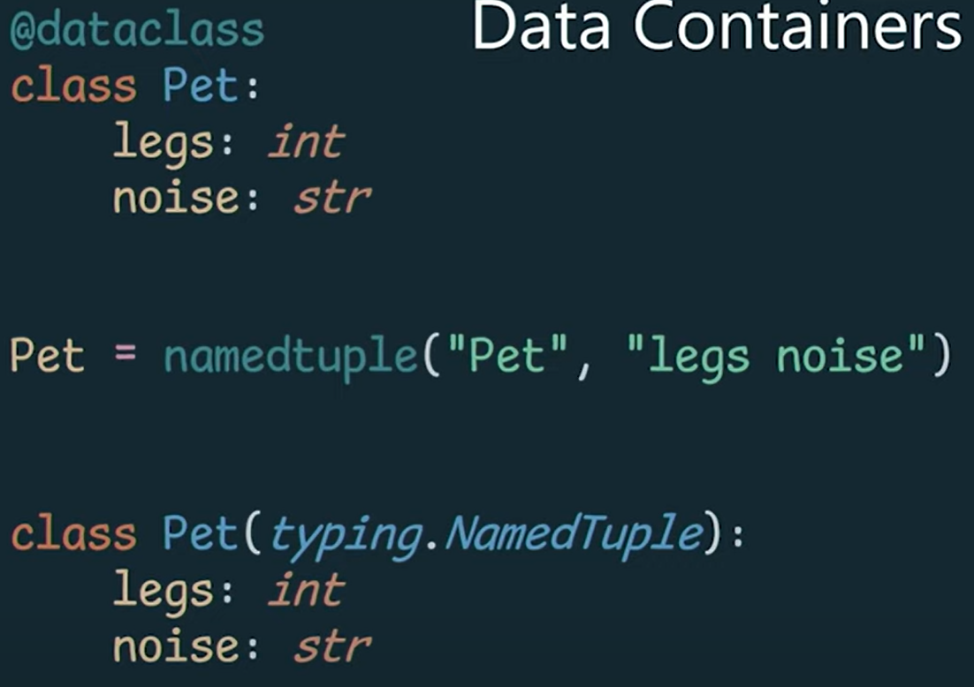

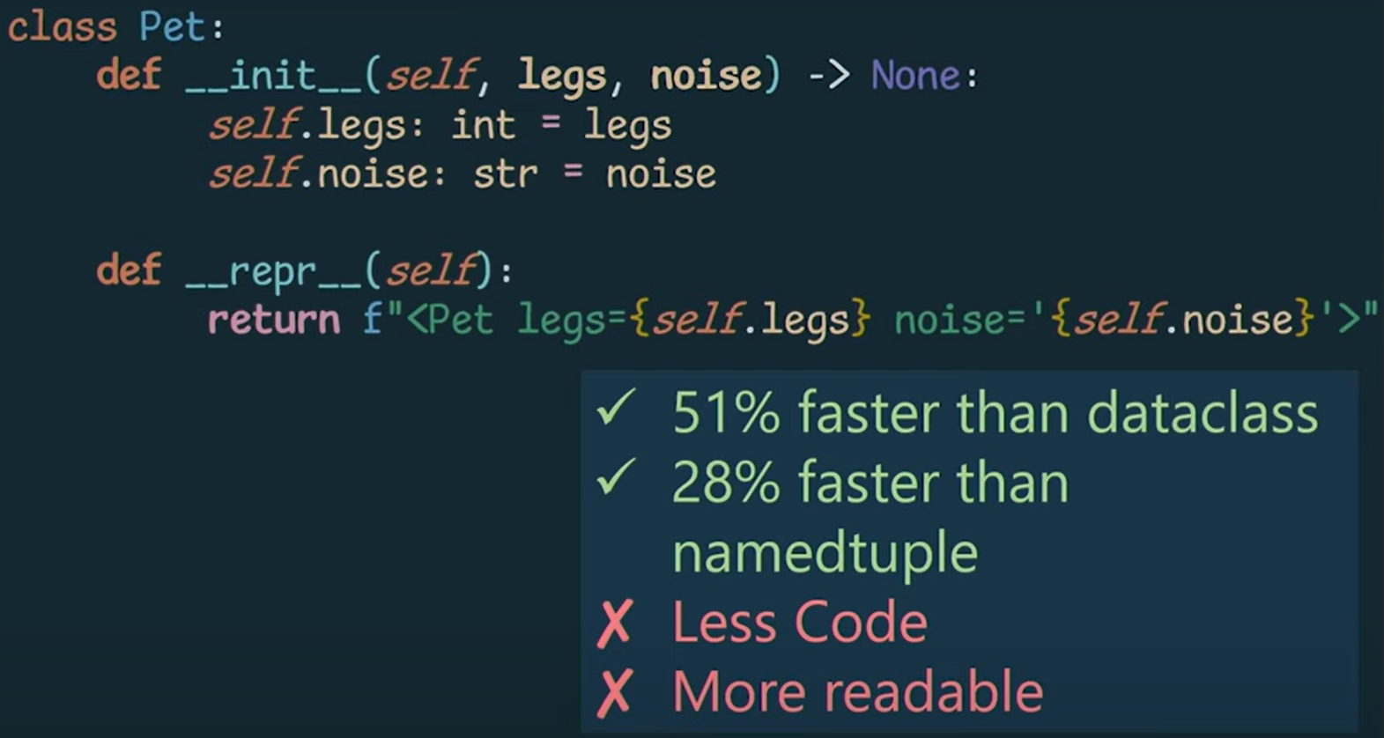

1. Avoid function call in hot areas of code

Function b() is faster

